**Salesforce Supported SmartInternz Virtual Internship Program Cohort-3-Salesforce Developer 23 Aug to 20 Oct 2023**

**Document for Additional Guided Project**

**“Property Management Application Using Salesforce - (Dev)”**

**Submitted By**

**NAME: ROUSHNI SINHA**

**EMAIL ID:** [**roushnisinha111@gmail.com**](mailto:roushnisinha111@gmail.com)

**Salesforce Externship Application ID :** SPS_APL_20230574206

|  |  |  |
| --- | --- | --- |
| **SBID** | **:** | **SB20230709952** |

**Date : 20/10/23**

**Property Management Application Using Salesforce - (DEV)**

Develop an App for the Property Management where Buyer can order his Requirements and get the Appropriate Details of the Property. According to his interest just provide him with some discounts up to what extent he can get the discount. Also track Whether he is Interested in taking the loan available for so just calculate how much loan amount the user can get it. Provide the Security for two different profiles like for marketing and sales team. Then finally create the reports and dashboard so there will be a clear view just get the reports on the count of loan passed getting the property purchased close to the deal.

### First step : Creating Developer Account

* Creating Developer Account
* Creating a developer org in salesforce.
* Go to developers.salesforce.com/Click on sign up.
* On the sign up form, enter the following details :
* First name & Last name
* Email
* Role : Developer
* Company : College Name
* County : India
* Postal Code : pin code
* Username : should be a combination of your name and company This need not be an actual email id, you can give anything in the format : username@organization.com
* Click on sign up after filling these.

**Sign up Developer Edition Link :** <https://developer.salesforce.com/signup>

**Second Step : Creation of Custom OBJECT : Enquiry , Property, Loan.**

**Object**

* What Is Object?
* Salesforce objects are database tables that permit you to store data that is specific to an organization. What are the types of Salesforce objects
* Salesforce objects are of two types:
* 1.Standard Objects: Standard objects are the kind of objects that are provided by salesforce.com such as users, contracts, reports, dashboards, etc.
* 2.Custom Objects: Custom objects are those objects that are created by users. They supply information that is unique and essential to their organization. They are the heart of any application and provide a structure for sharing data.

1.1Creation of Enquiry Object:

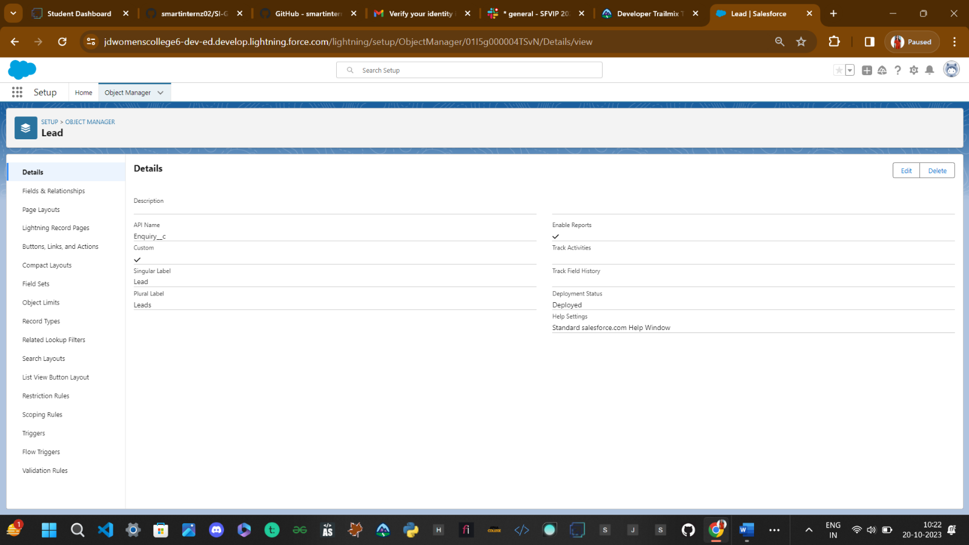

**1.2 Creation of Property Object:**

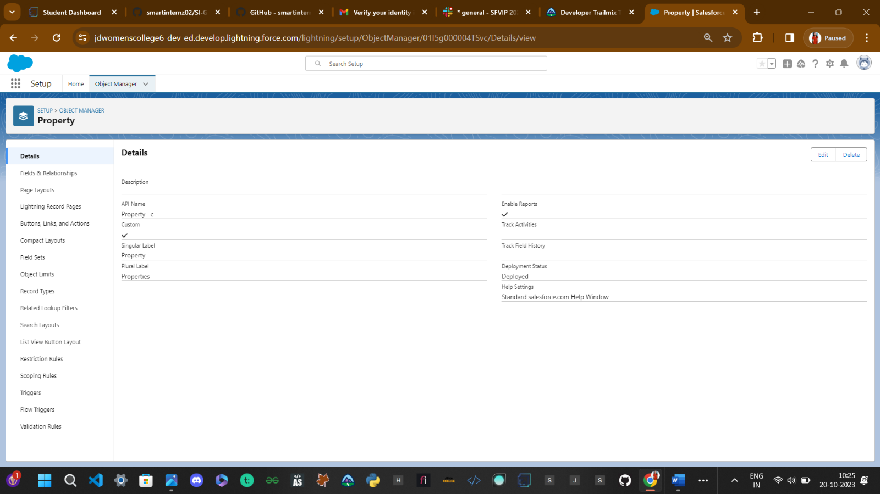

**1.3Creation of Loan Object:**

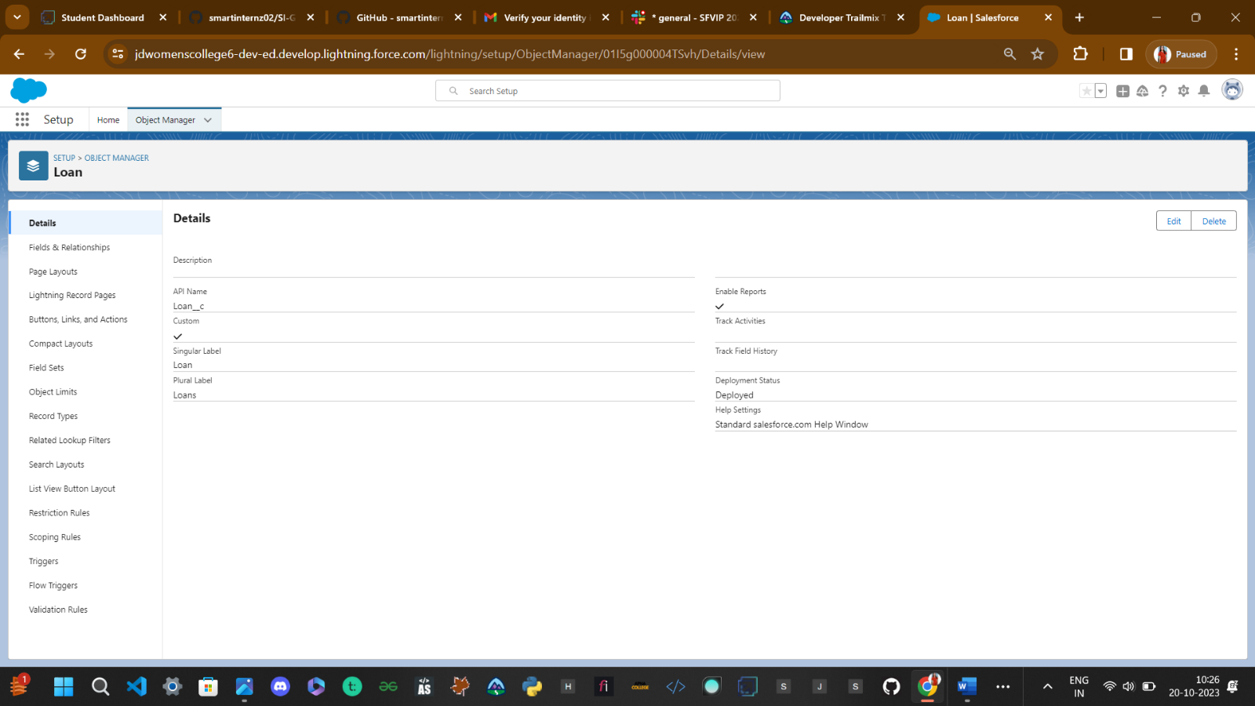

**Step 3 : Creation of Lightning Custom Tab**

**Tabs**: 1.Enquiry Tab , 2. Property Tab , 3. Loan Tab

* What is Tab?  
  A tab is like a user interface that is used to build records for objects and to view the records in the objects.  
    
  1.Types of Tab  
  2.Custom object tab 3.Web tab 4.Visualforce tab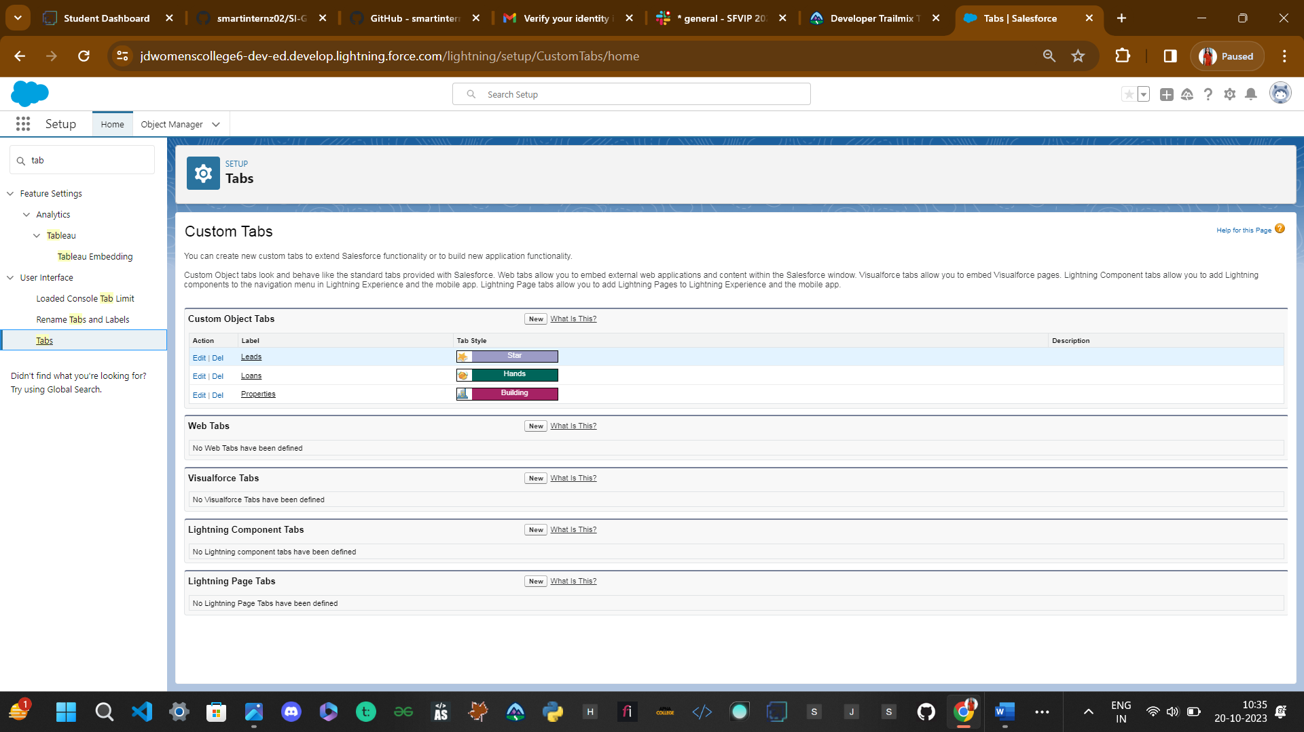  
    
  **Step 4: Created a Lightining APP (Property Management)**
* The Lightning App
* An app is a collection of items that work together to serve a particular function. In Lightning Experience, Lightning apps give your users access to sets of objects, tabs, and other items all in one convenient bundle in the navigation bar.  
  Lightning apps let you brand your apps with a custom color and logo. You can even include a  
  utility bar and Lightning page tabs in your Lightning app. Members of your org can work more efficiently by easily switching between apps.

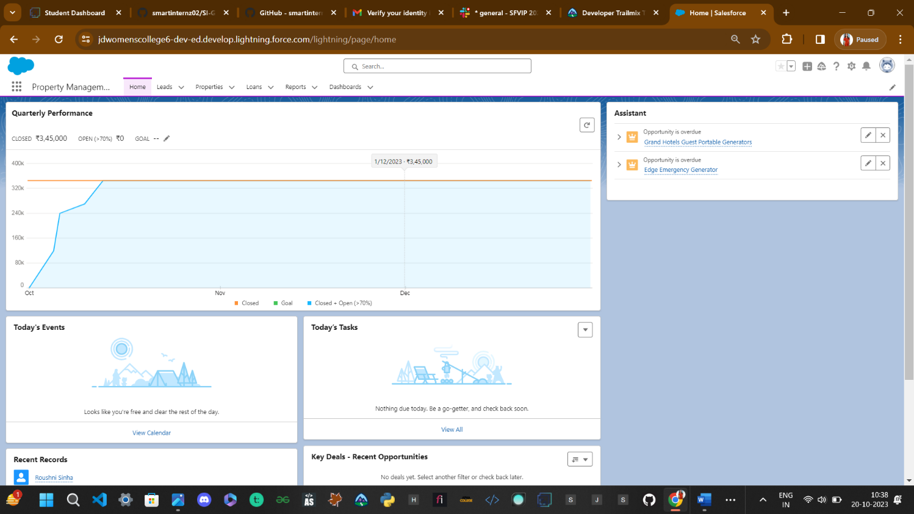

**Step 5: Creation Of FIELDS**

### Fields

* When we talk about Salesforce, Fields represent the data stored in the columns of a relational database. It can also hold any valuable information that you require for a specific object. Hence, the overall searching, deletion, and editing of the records become simpler and quicker.  
    
  Types of Fields  
  1.Standard Fields  
  2.Custom Fields  
    
  **Standard Fields:**  
  As the name suggests, the Standard Fields are the predefined fields in Salesforce that perform a standard task. The main point is that you can’t simply delete a Standard field until it is a non- required standard field. Otherwise, users have the option to delete them at any point from the application freely. Moreover, we have some fields that you will find common in every Salesforce application. They are,  
  1.Created By  
  2.Owner  
  3.Last Modified  
    
  **Custom Fields:**  
  On the other side of the coin, Custom Fields are highly flexible, and users can change them according to requirements. Moreover, each organizer or company can use them if necessary. It means you need not always include them in the records, unlike Standard fields. Hence, the final decision depends on the user, and he can add/remove Custom Fields of any given form.

**5.1Enquiry Object’s Custom Fields:**

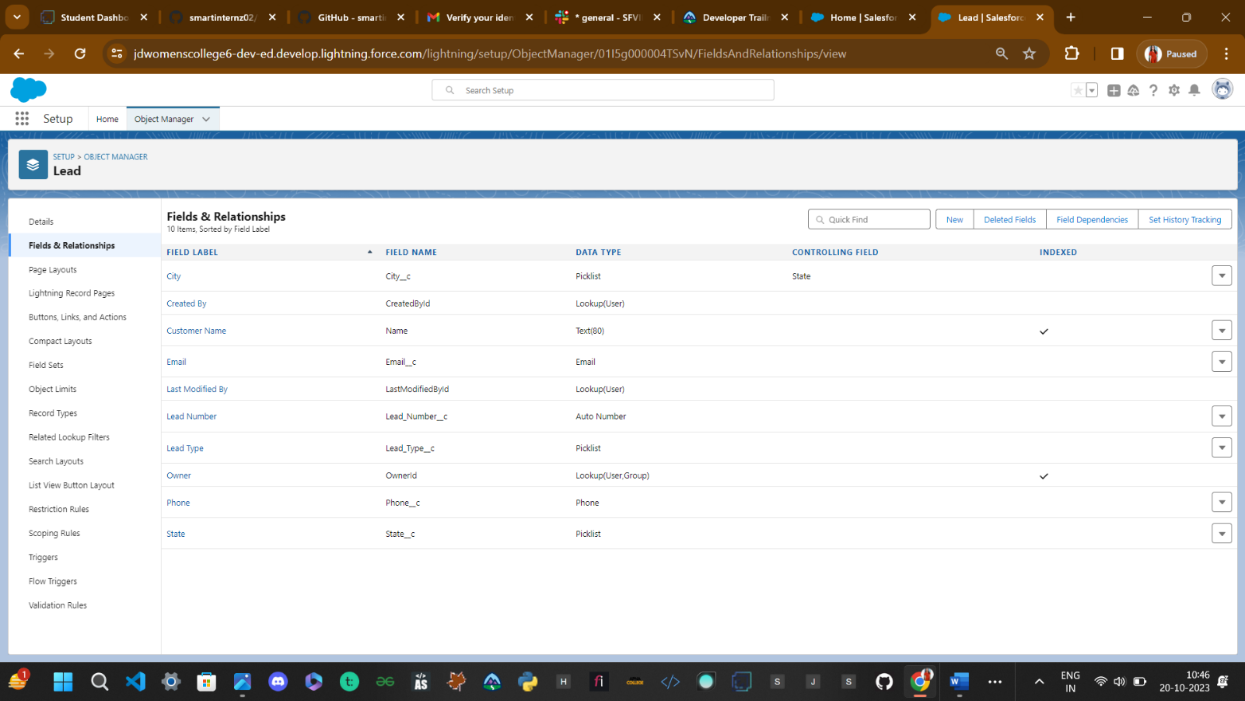

**5.2 Property Object’s Custom Field:**

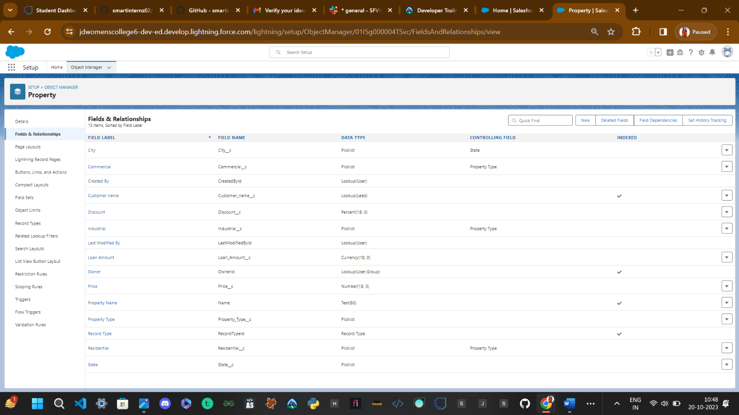

**5.3 Loan Object’s Custom Field:**

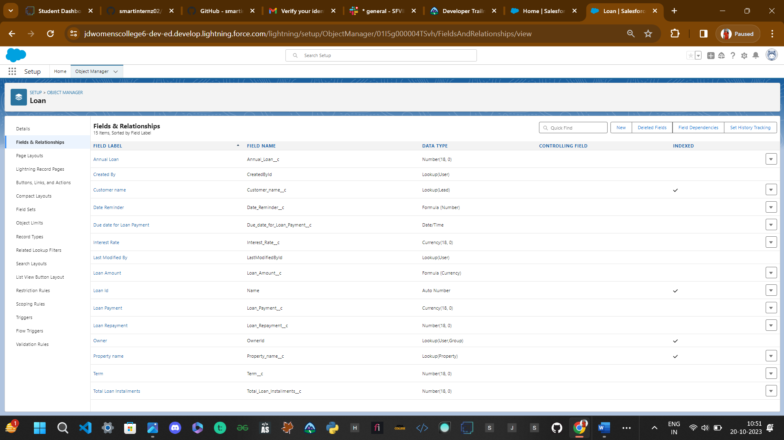

**Step 6: Create Page Layout AND Record Types**

**6.1 Property Page Layout:**

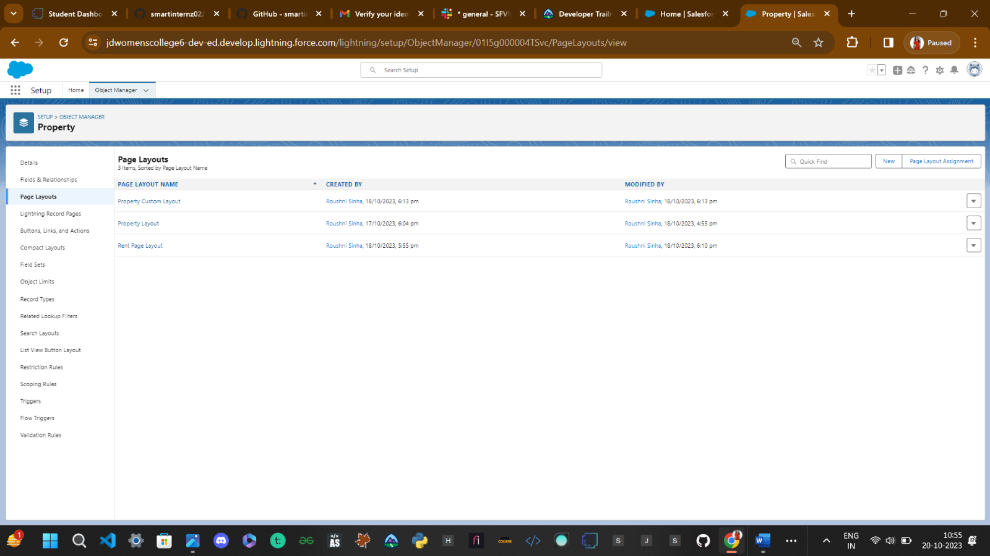

**6.2 Record Type for Property Object:**

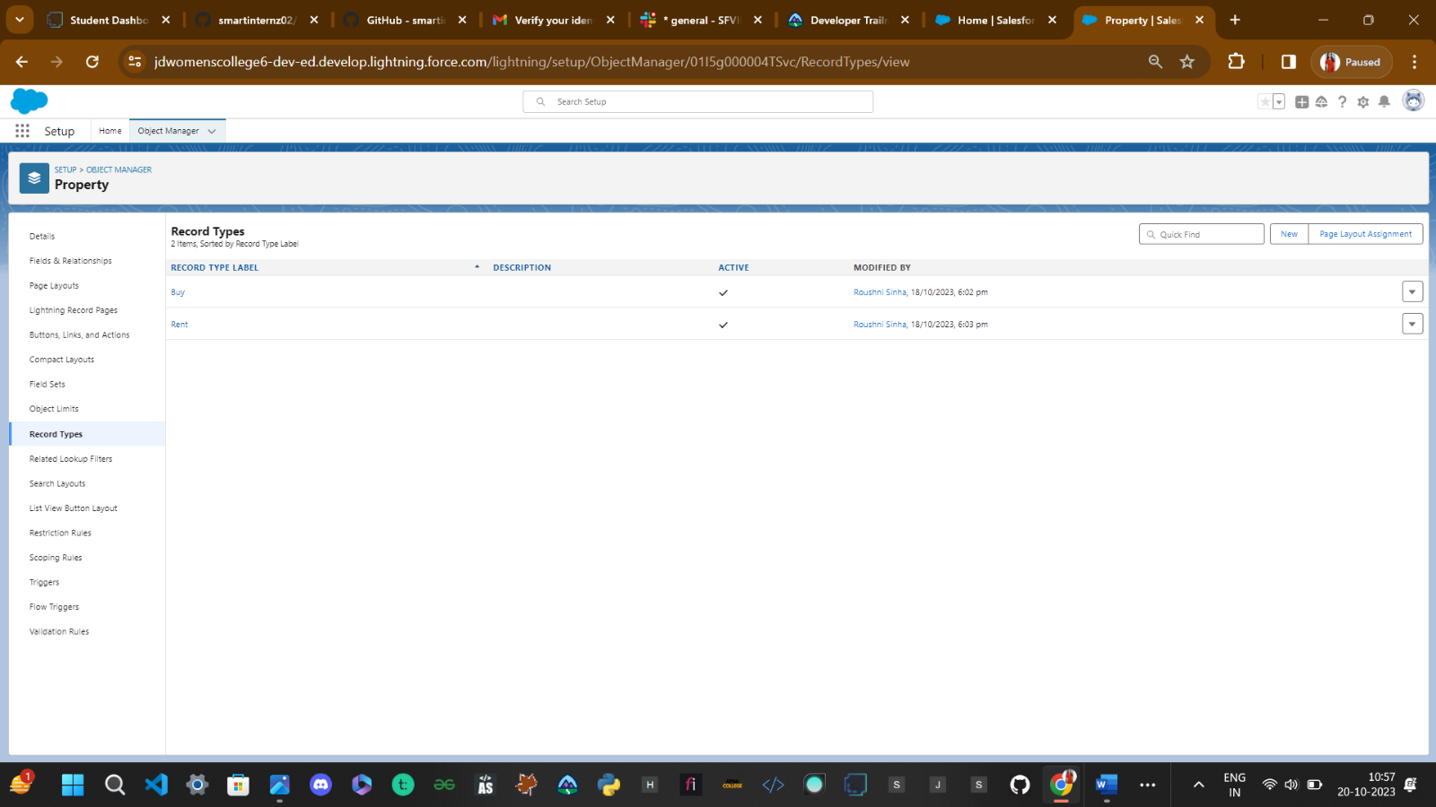

**6.3 Property Object’s Page Layout Assignment:**

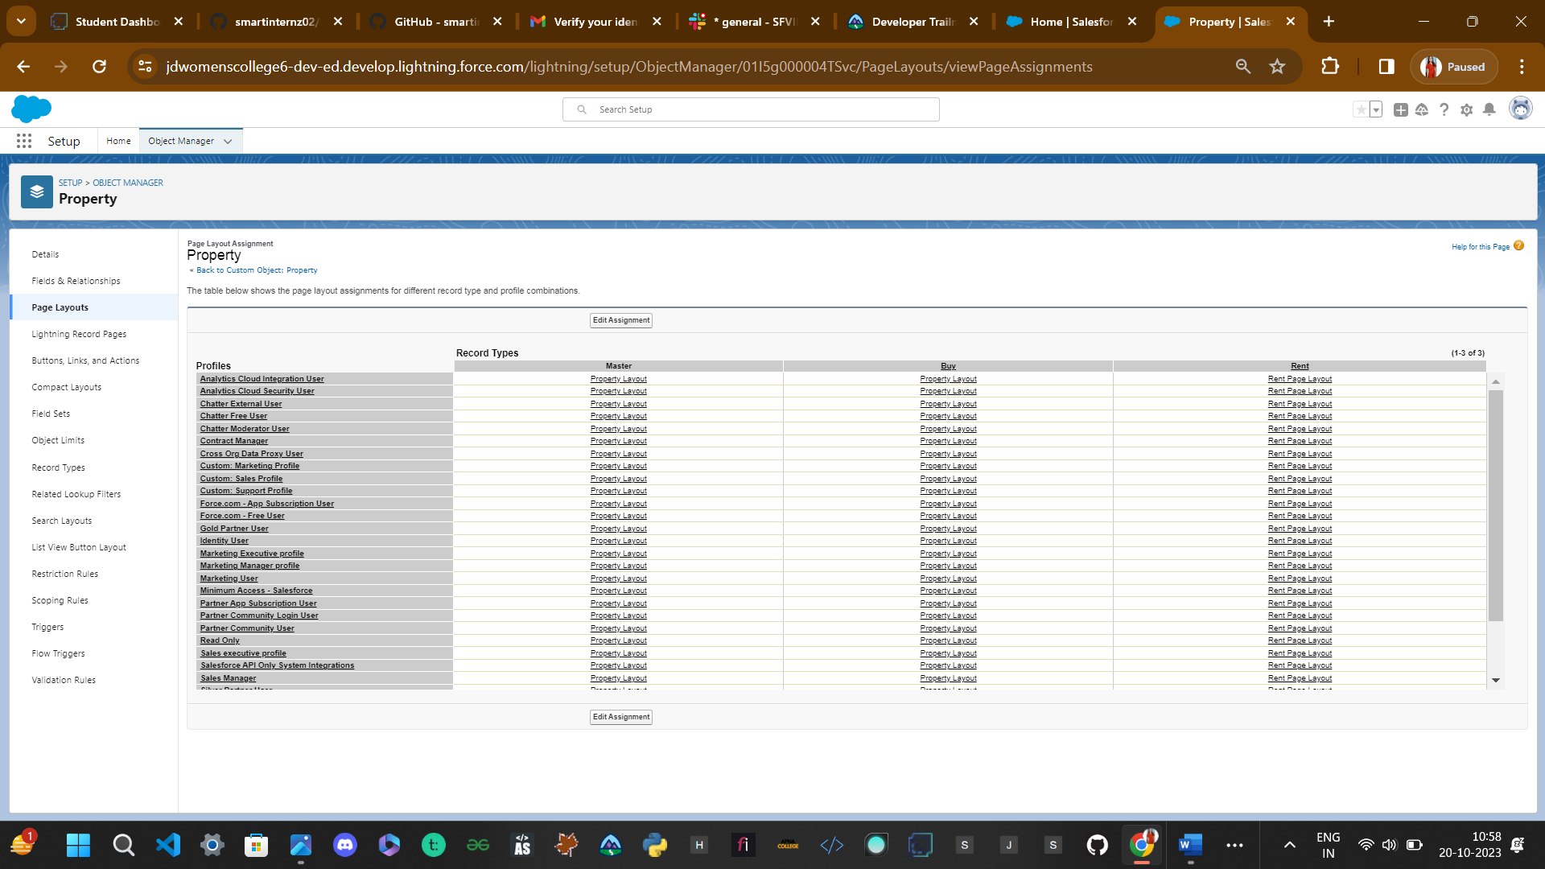

**STEP 7:Creation Of New Profile**

### Profile

1. A profile is a group/collection of settings and permissions that define what a user can do in salesforce.
2. Profile controls “Object permissions, Field permissions, User permissions, Tab settings, App settings, Apex class access, Visualforce page access, Page layouts, Record Types, Login hours & Login IP ranges.
3. You can define profiles by the user's job function. For example System Administrator, Developer, Sales Representative.

Types of profiles in salesforce   
Standard profiles:

1. By default salesforce provide below standard profiles.
2. We cannot deleted standard ones
3. .Each of these standard one includes a default set of permissions for all of the standard objects available on the platform.

Custom Profiles:

Custom ones defined by us.  
They can be deleted if there are no users assigned with that particular one.

**7.1Creation Of 4 New Profile – Sales Manager Profile, Marketing Manager Profile, Marketing Executive Profile, Sales Executive Profile**

Go to setup -> type profiles in quick find box -> click on profiles -> clone the desired profile (standard user Platforom is recommended).

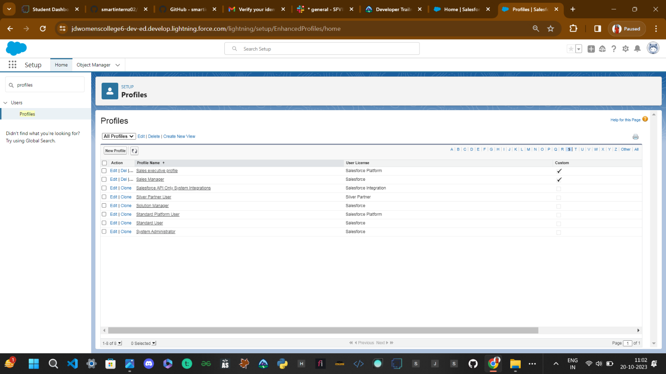

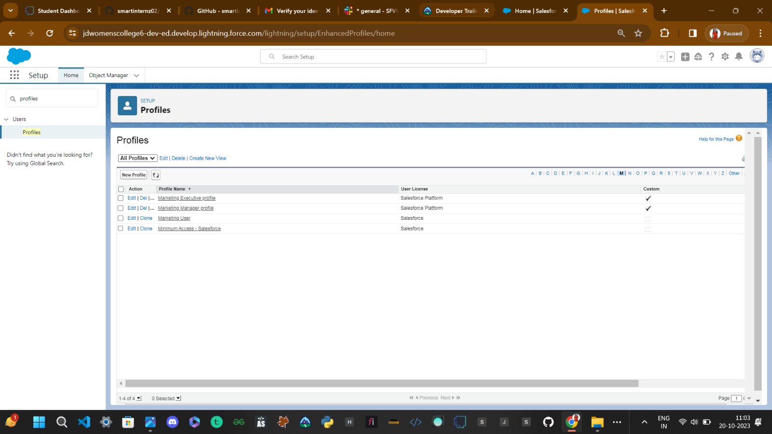

**7.2SALES MANAGER PROFILE:**

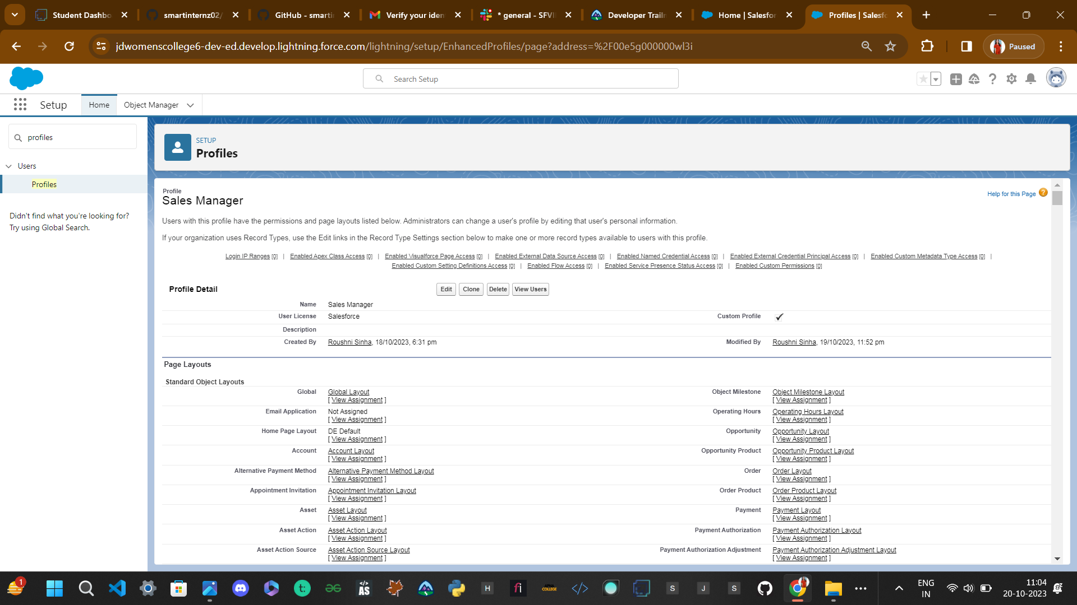

**7.3MARKETING EXECUTIVE PROFILE**

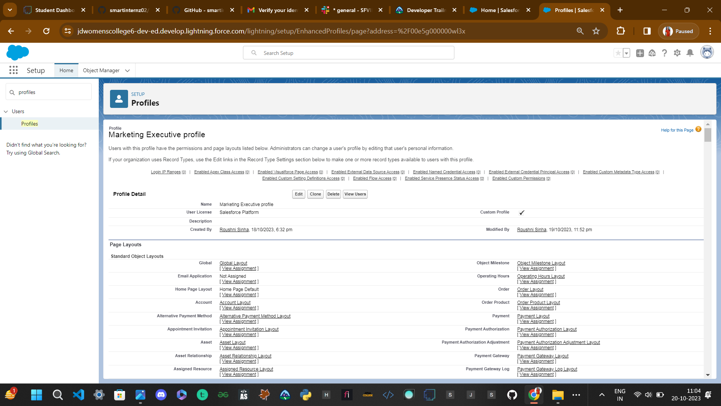

**7.4MARKETING MANAGERPROFILE:**

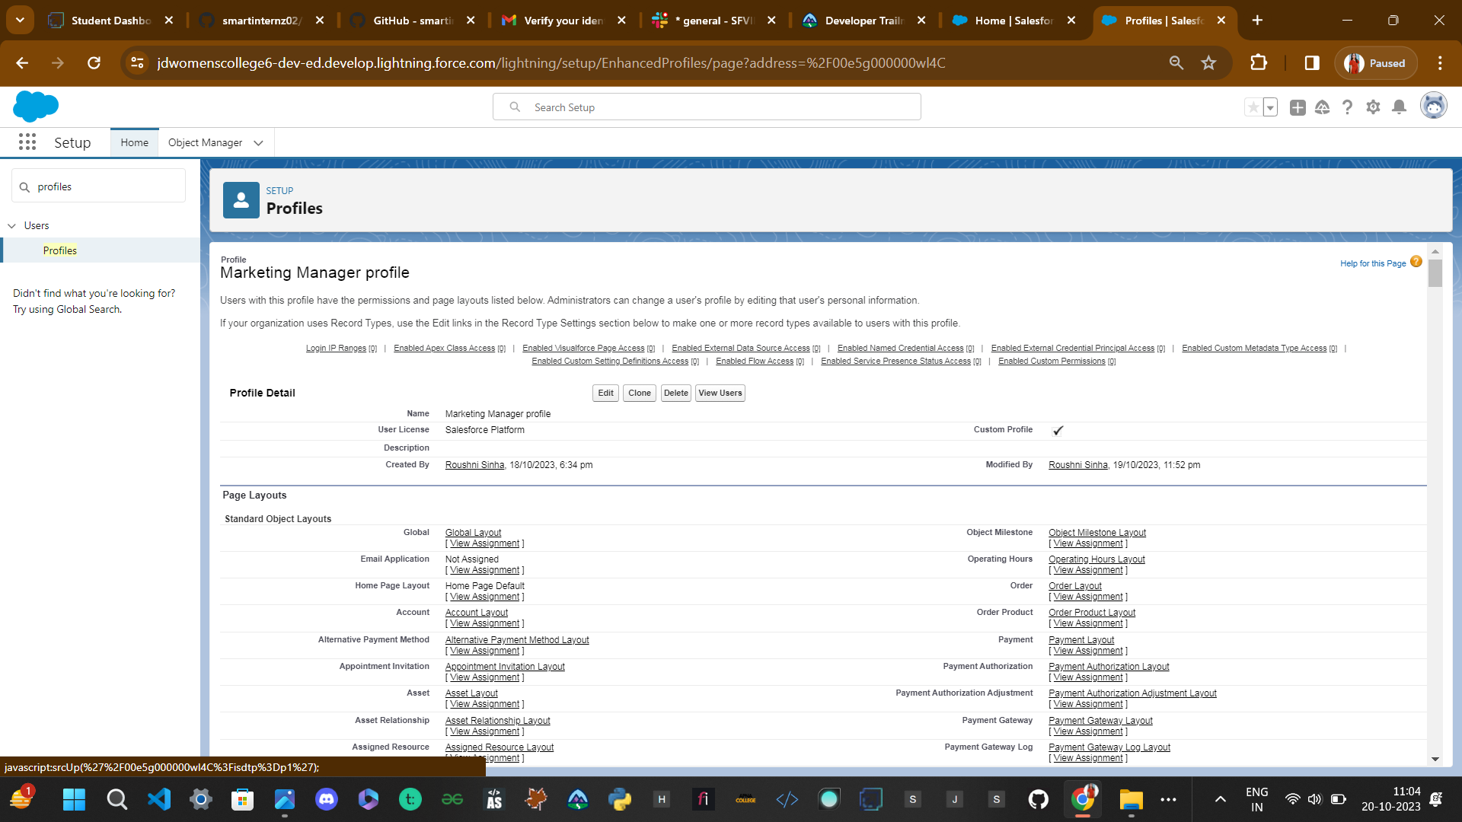

**7.5 SALES EXECUTIVE PROFILE:**

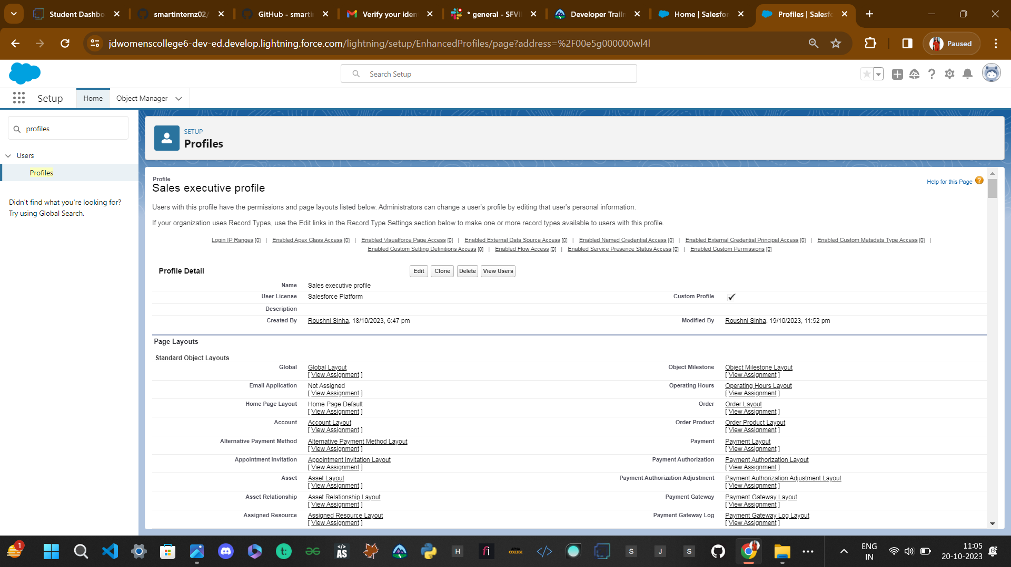

**Step8: CREATE USER**

Go to setup -> type profiles in quick find box -> click on profiles ->clone the desired profile (standard user is preferable).

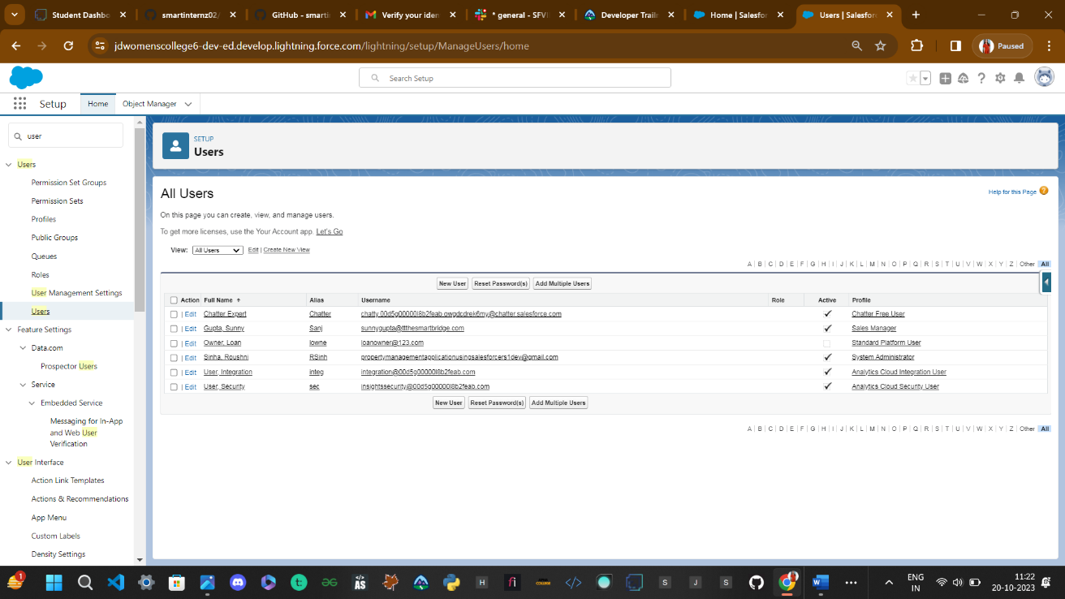So create profile:

First Name: Sunny  
Last Name: Gupta  
Alias: Sanj  
Email: provide your personal email id for future reference  
Username: sunnygupta@thesmartbridge.com  
  
Nickname: Sunny  
Role: leave it as default  
User License: Salesforce  
Profile: Sales Manager and Click Save Button.

8.1Create User: Sunny Gupta

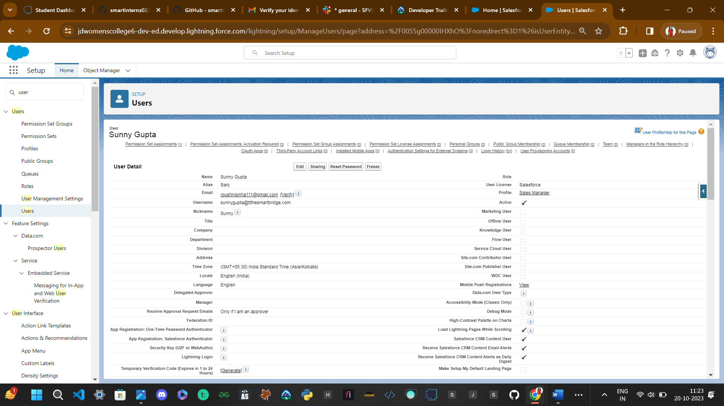

Step9: Create Permission Set

Permission Set: A permission set is a collection of settings and permissions that give users access to various tools and functions. Permission sets extend users' functional access without changing their profiles. Users can have only one profile but, depending on the Salesforce edition, they can have multiple permission sets.

1. Go to setup -> type “permission sets” in quick search -> select permission sets –> New
2. Enter the label name (Sales Rep Advance) -> save
3. Select Object settings
4. Search object property and select property object. and click Edit button
5. In Object Permission we give View all permission. And click save button
6. Repeat 4th and 5th steps for Enquiry and Loan objects.
7. After saving the permission click on the Manage assignment
8. Go to setup -> type “permission sets” in quick search -> select permission sets –> New
9. Enter the label name (Sales Rep Advance) -> save
10. Select Object settings
11. Search object property and select property object. and click Edit button
12. In Object Permission we give View all permission. And click save button
13. Repeat 4th and 5th steps for Enquiry and Loan objects.
14. After saving the permission click on the Manage assignment

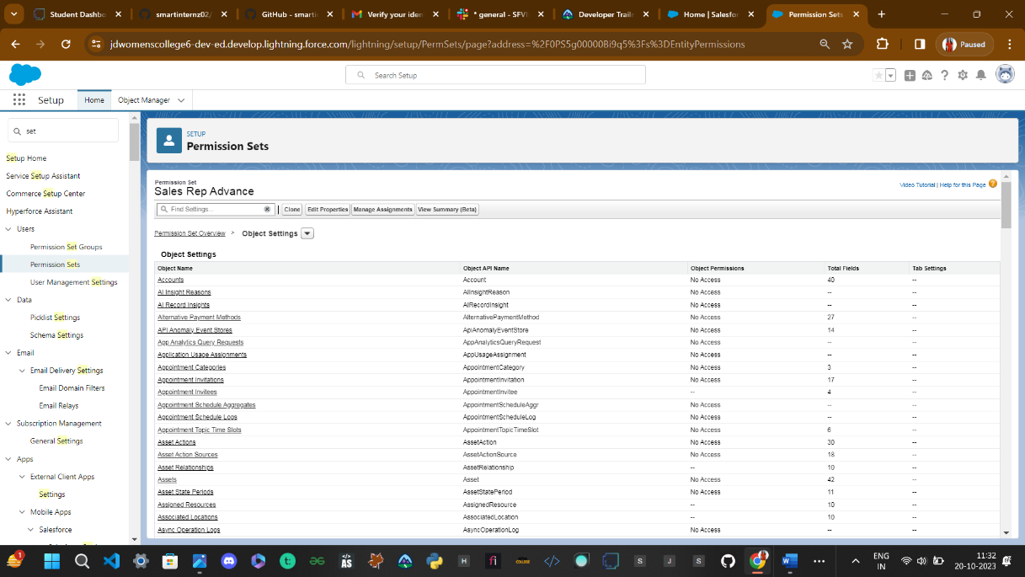

9.1 SET PERMISSION in Property Object: 9.1.1 first search property object

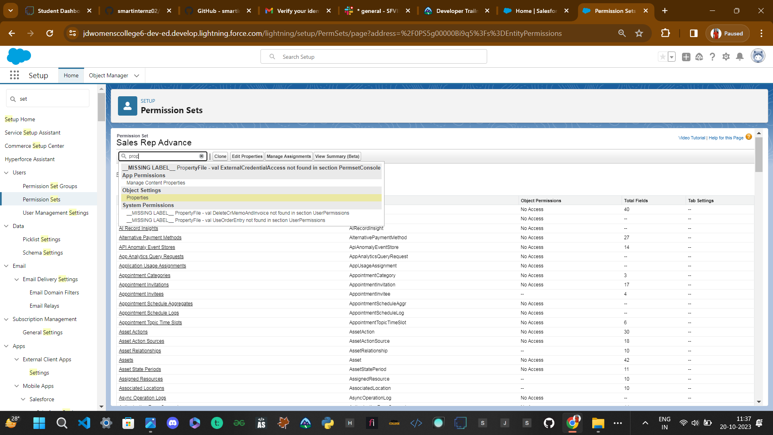

9.1.2 In Object Permission give View all permission

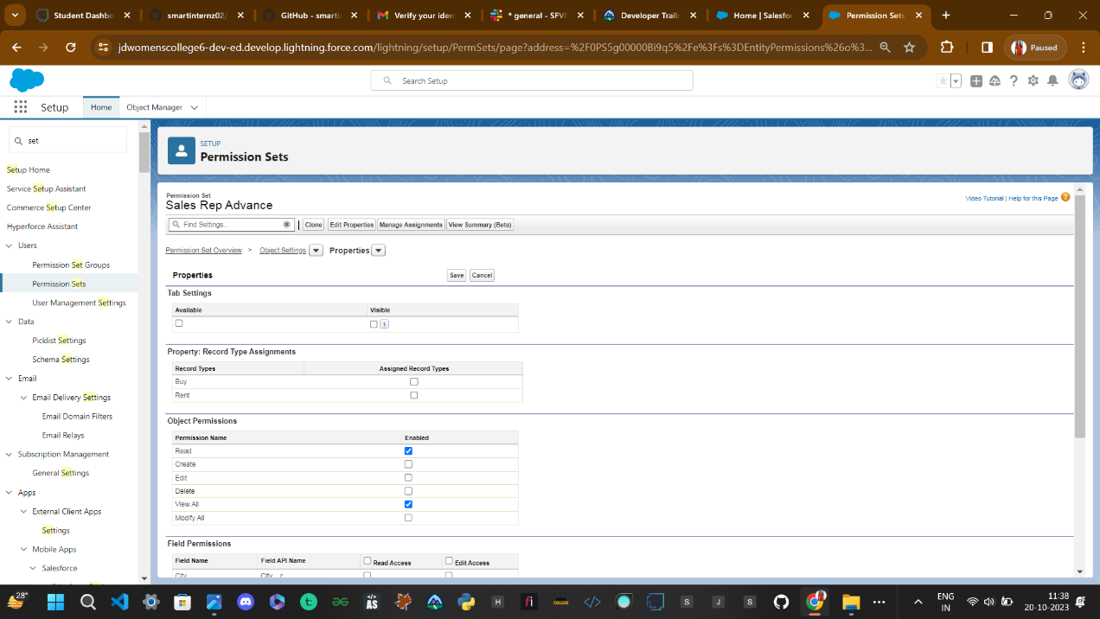

**9.2 Give View All permission to 9.3 Give View All permission to**

**Loan Object Lead(Enquiry_c) object**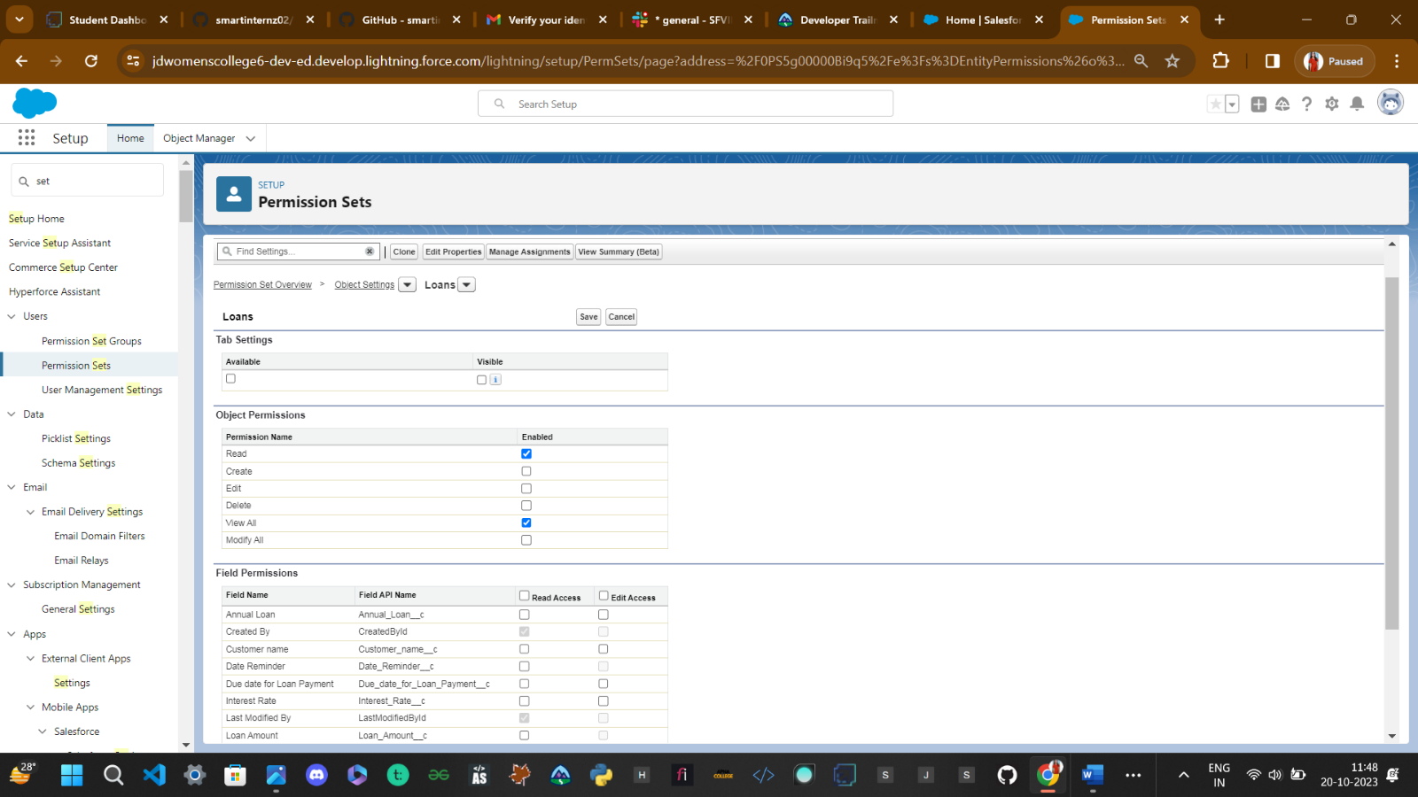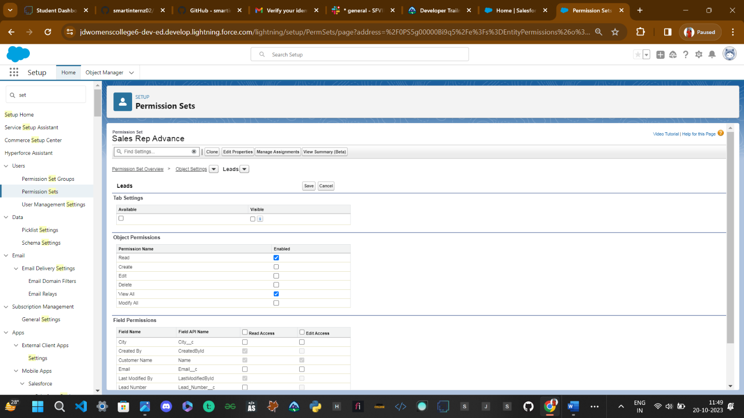

**9.4 Click on Manager Assignment and ASSIGN User ->Sunny Gupta**

**As a Sales Manager.**

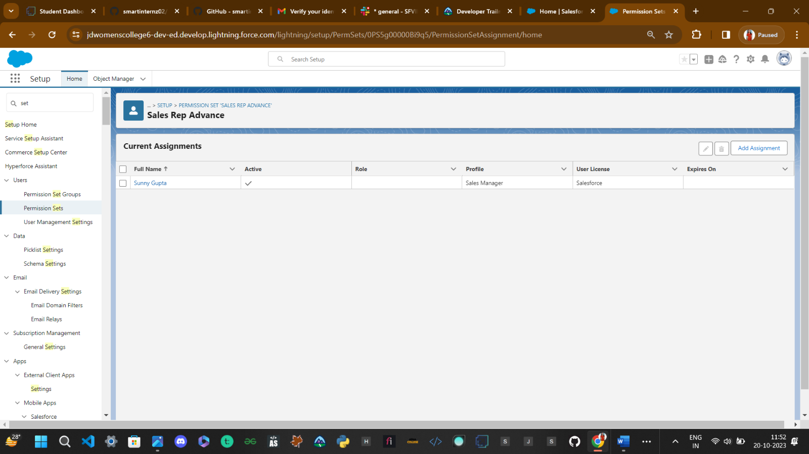

**Step 10: Create (OWD) Organization-Wide-Adresses Settings.**

### Set Up For OWD

Organization-Wide Defaults, or OWDs, are the pattern security rules that you can follow for your Salesforce instance. Organization Wide Defaults are utilized to confine who can access what information in your CRM. You can award access through different methods that we will discuss later (sharing principles, Role Hierarchy, Sales Teams, and Account groups, manual sharing, and so forth).  
  
Primarily, there are four levels of access that can be set in Salesforce OWD and they are-

1. Public Read/Write/Transfer (only available of Leads and Cases)
2. Public Read/Write
3. Public Read/Only
4. Private

Steps to Create OWD Settings:

1.Setup, use the Quick Find box to find Sharing Settings.  
2.Click Edit in the Organization-Wide Defaults area.  
3.For each object, select the default access you want to give everyone.  
4.To disable automatic access using your hierarchies, deselect Grant Access Using Hierarchies for Enquiry, Property custom object

5.Click Edit and from the Drop Down select private for internal and external  
6.This Setting is for all the User Which have been Created

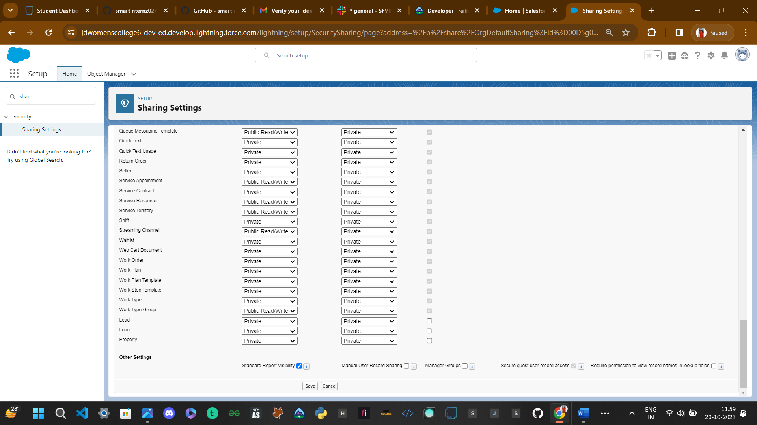

**Step 11: User Adoption**

### 11.1 Create A Record Lead(Enquiry)

1.Click on App Launcher on left side of screen. 2.Search Property Management & click on it. 3.Click on Leads Tab. 4.Click new and fill details & Save.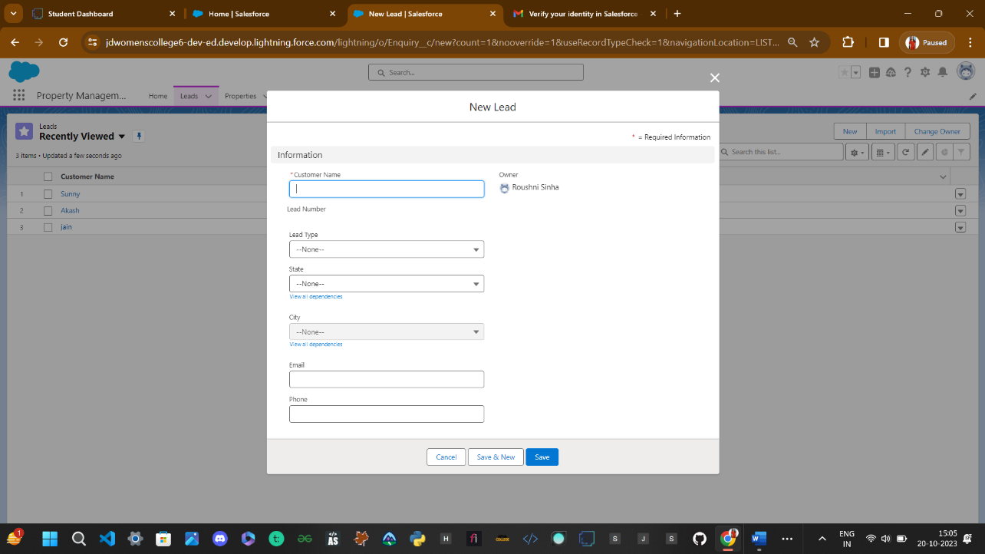

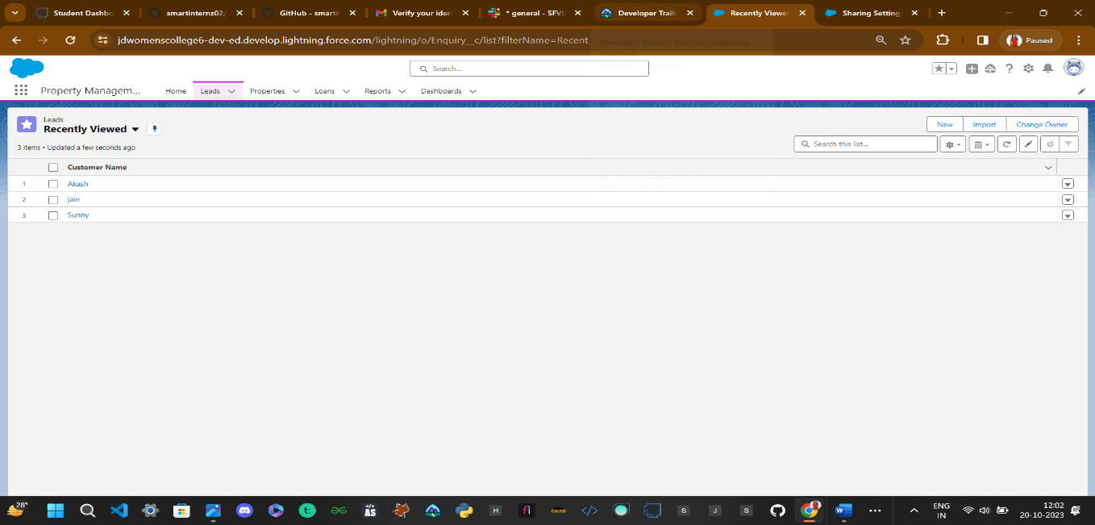

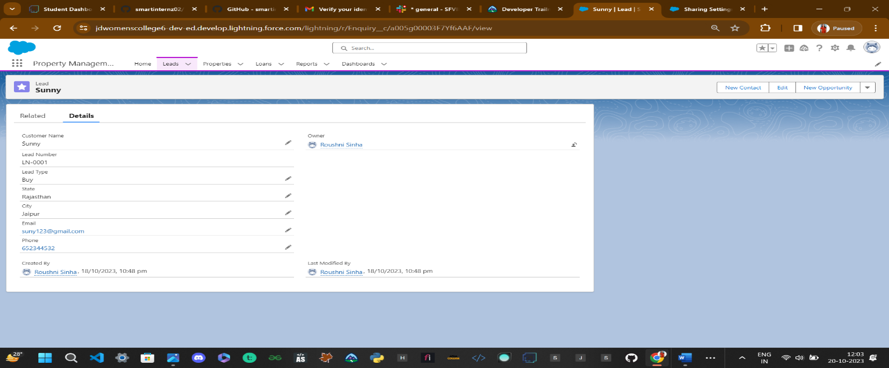**11.2View a record Lead(Enquirey**)

1. Click on App Launcher on left side of screen.
2. Search Property Management & click on it.
3. Click on Inquiries Tab.
4. Click on any record name. you can see the details of the Even

**11.3 Delete A Record Lead(Enquiry)**

1. Click on App Launcher on left side of screen.
2. Search Property Management & click on it.
3. Click on Inquiries Tab.
4. Click on Arrow at right hand side on that Particular record.
5. Click delete and delete again.

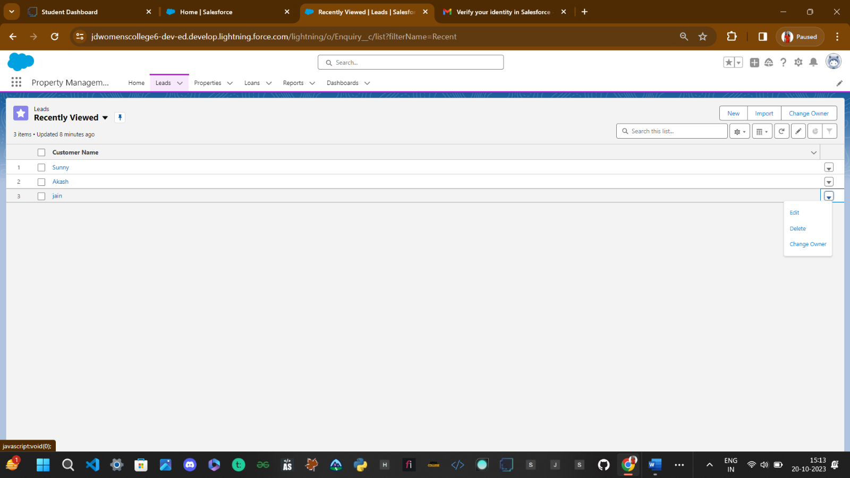

**Step12: Create Report**

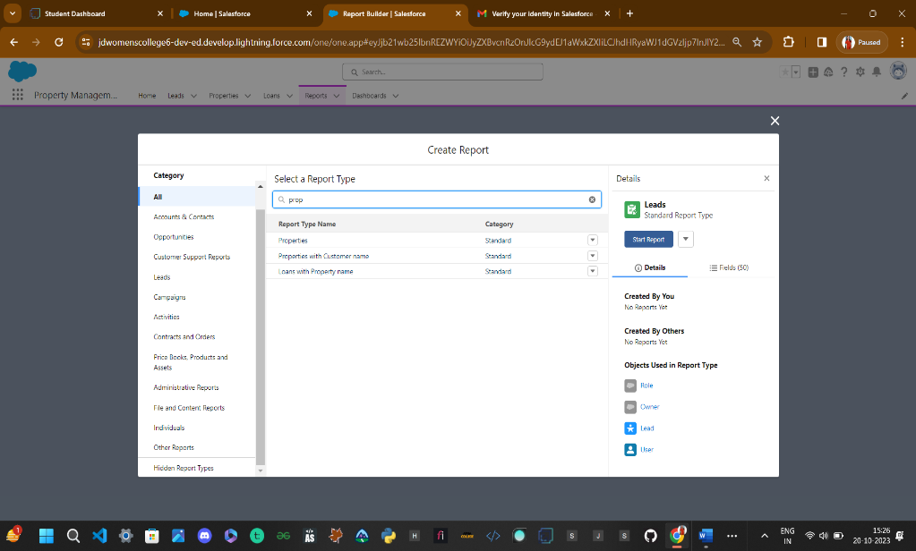**Report:** Reports give you access to your Salesforce data. You can examine your Salesforce data in almost infinite combinations, display it in easy-to-understand formats, and share the resulting insights with others. Before building, reading, and sharing reports, review these reporting basics.  
   
Types of Reports in Salesforce

* Tabular
* Summary
* Matrix
* Joined Reports

Steps to create the Report:

Go to the app ->

click on the reports tab ->

Click New Report->

-> Select report type from category or from report type panel or from search panel (properties with customer name) ->

click on start report.

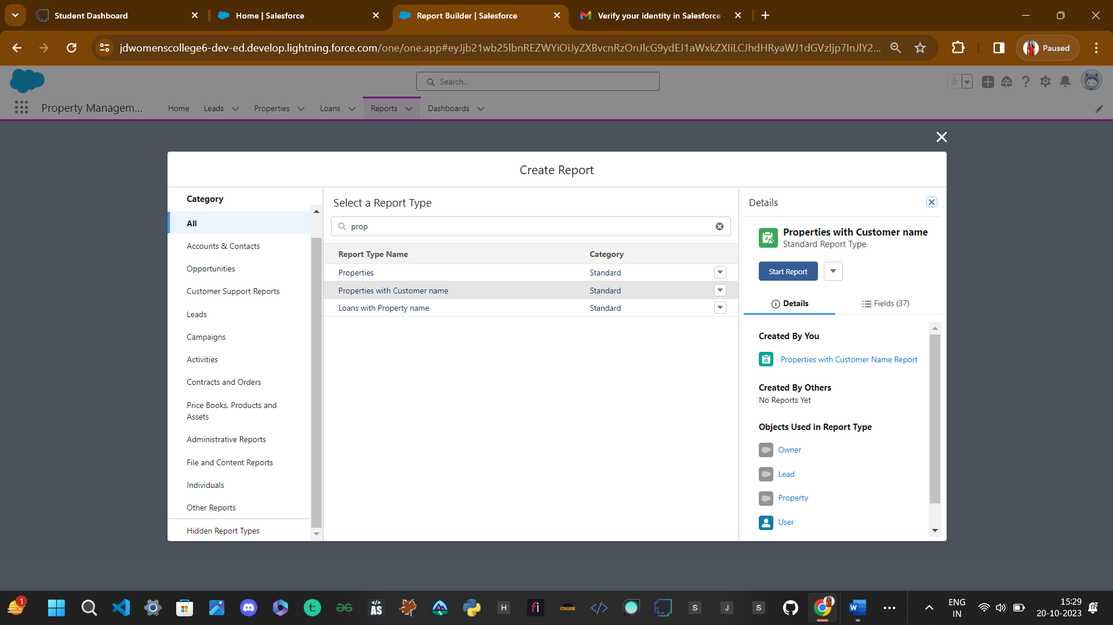

-> Customize your report, add fields like property name, customer name, city, property type etc. Click on save& run (Properties with Customer Name Report)

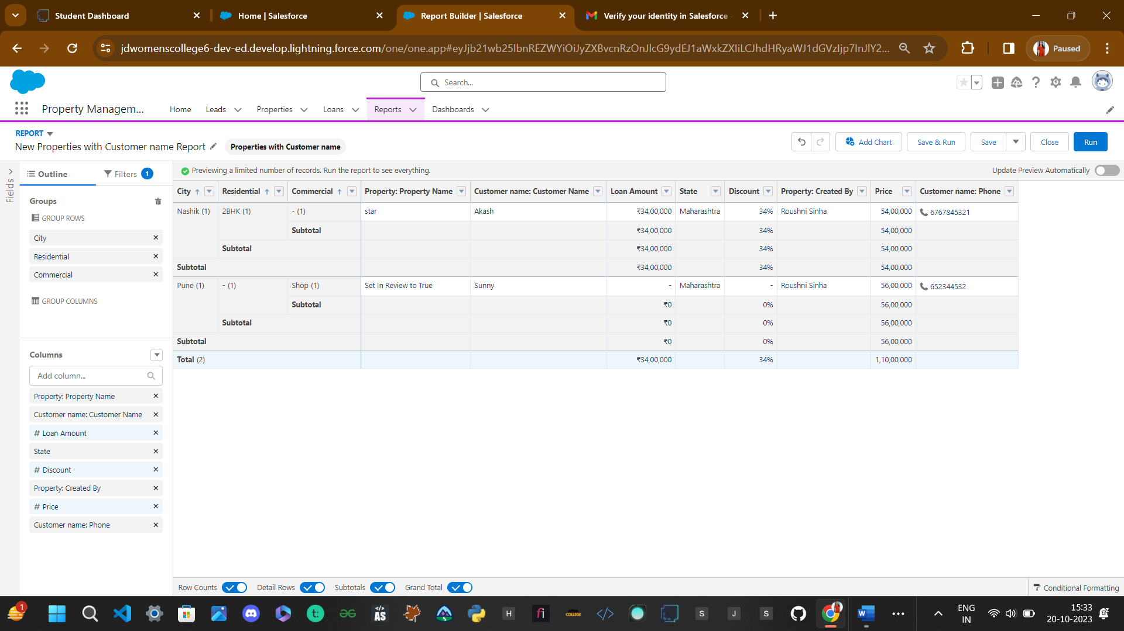

-> Create Report for following Condition

->Create the Report of the Total Number of Loan Passed for getting the Amount For the Property

->The Condition should be Like Loan Amount >= to 5000$

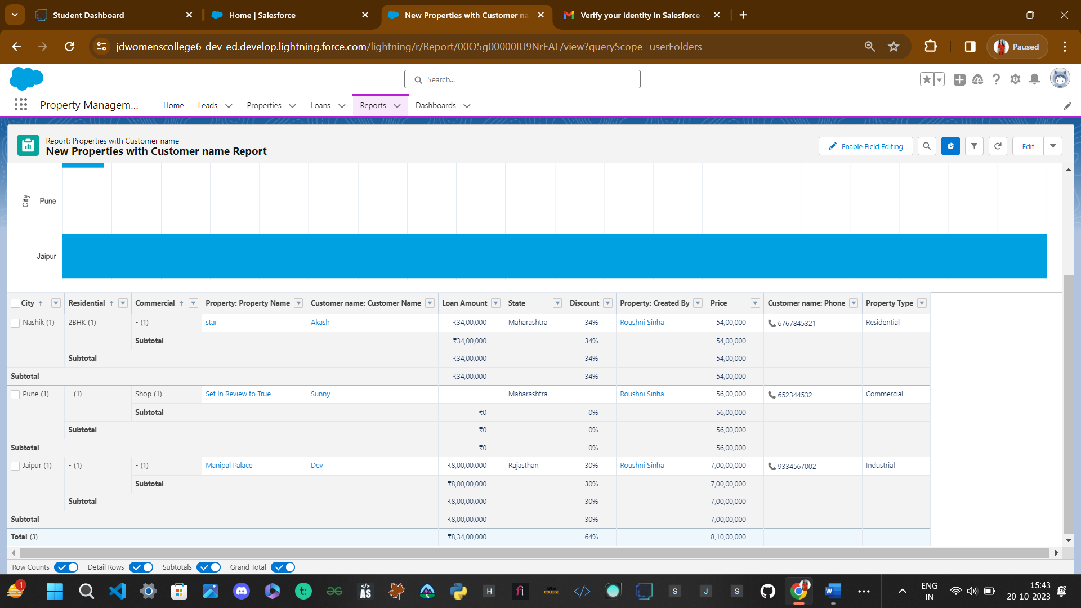

**Steps13: Create Dashboards**

**Dashboards:** Dashboards help you visually understand changing business conditions so you can make decisions based on the real-time data you’ve gathered with reports. Use dashboards to help users identify trends, sort out quantities, and measure the impact of their activities. Before building, reading, and sharing dashboards, review these dashboard basics.

Steps to create a Dashboard:->

1.Click the Dashboards tab.  
2.Click New Dashboard.

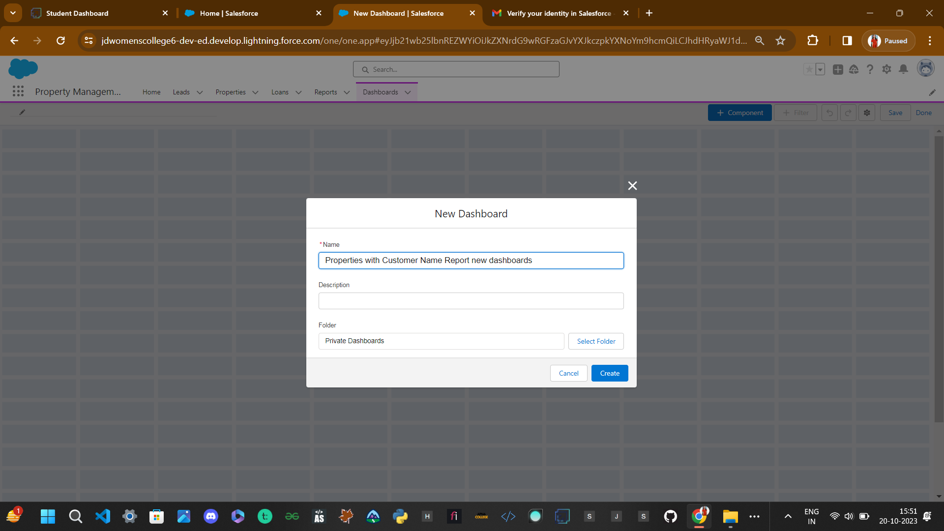

3.Name the Properties with Customer Name Report and click Create.  
4.Click +Component.  
5.Select the Properties with Customer Name Report and click Select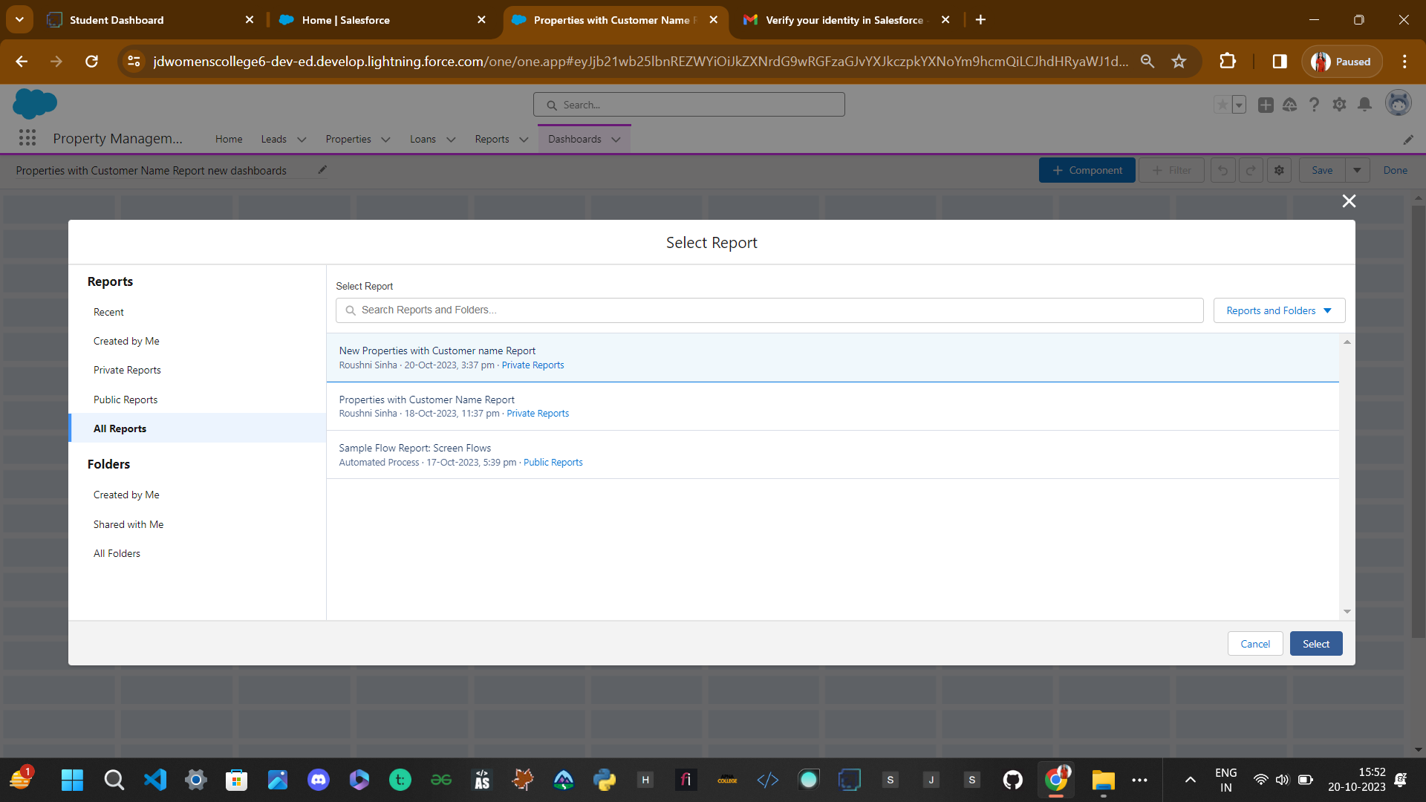

6.Select the Vertical Bar Chart or any chart component(select in which format you want display chart and click Add.  
7.Click Save and then Done.

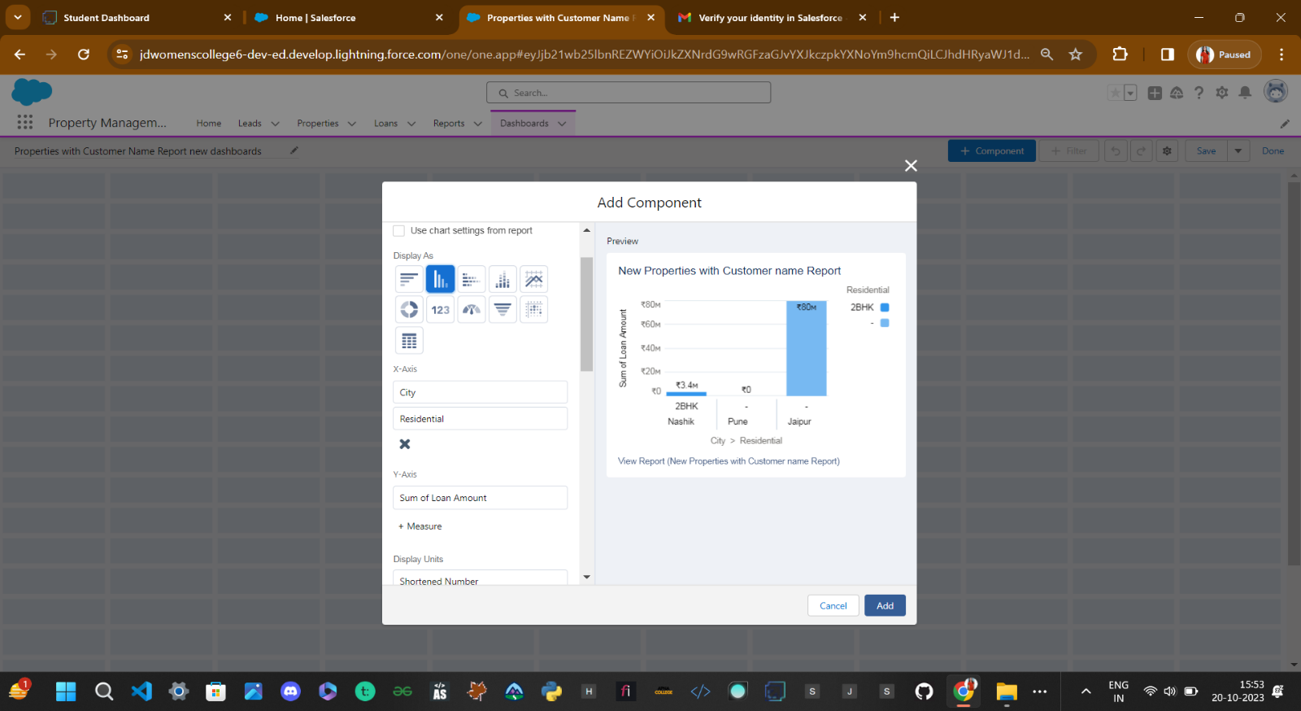

**Steps14:Flow Builder**

**Flow Builder :** Flows In Salesforce, a flow is a tool that automates complex business processes. Simply put, it collects data and then does something with that data.

Flow Builder is the declarative interface used to build individual flows.

Flow Builder can be used to build code-like logic without using a programming language. Flows fall into five categories:

* Screen Flows
* Schedule-Triggered Flows
* Autolaunched Flows
* Record-Triggered Flows
* Platform Event-Triggered Flows

**14.1Classic Email Templates**

**Note**: For creating this flow you have to create the “Due date for Loan Payment” field in the loan object with date and time field data type and api-name “Due_date_for_Loan_Payment”

->

And also have to create a formulae field” Date Remainder” in Loan Object.

With formulae -> [ DATEVALUE(Due_date_for_Loan_Payment__c) - TODAY() ]

**14.1.1 two field of LoanObject**

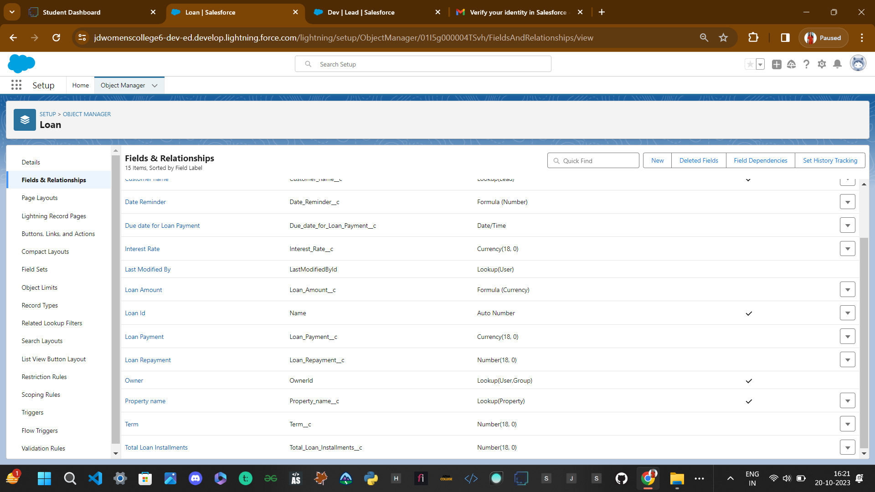

Due date for Loan Payment field of Loan Object

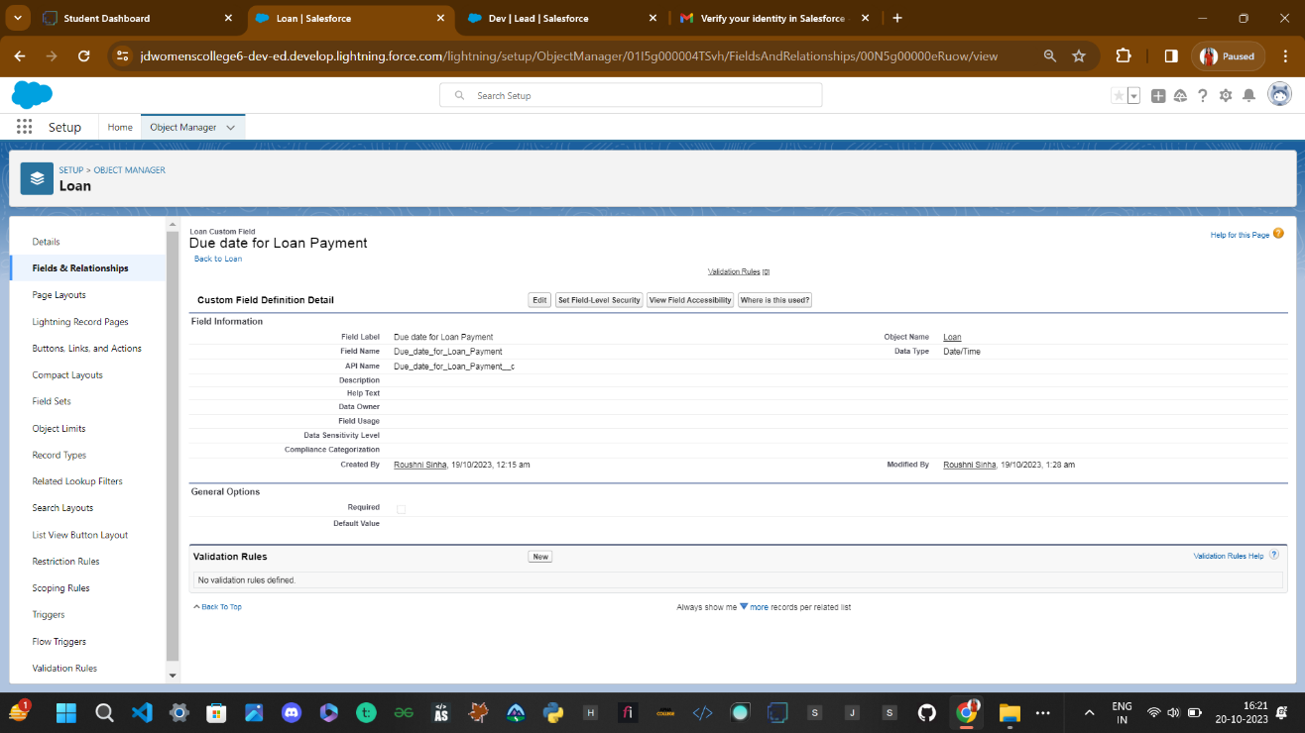

Date reminder Field in Loan Object->

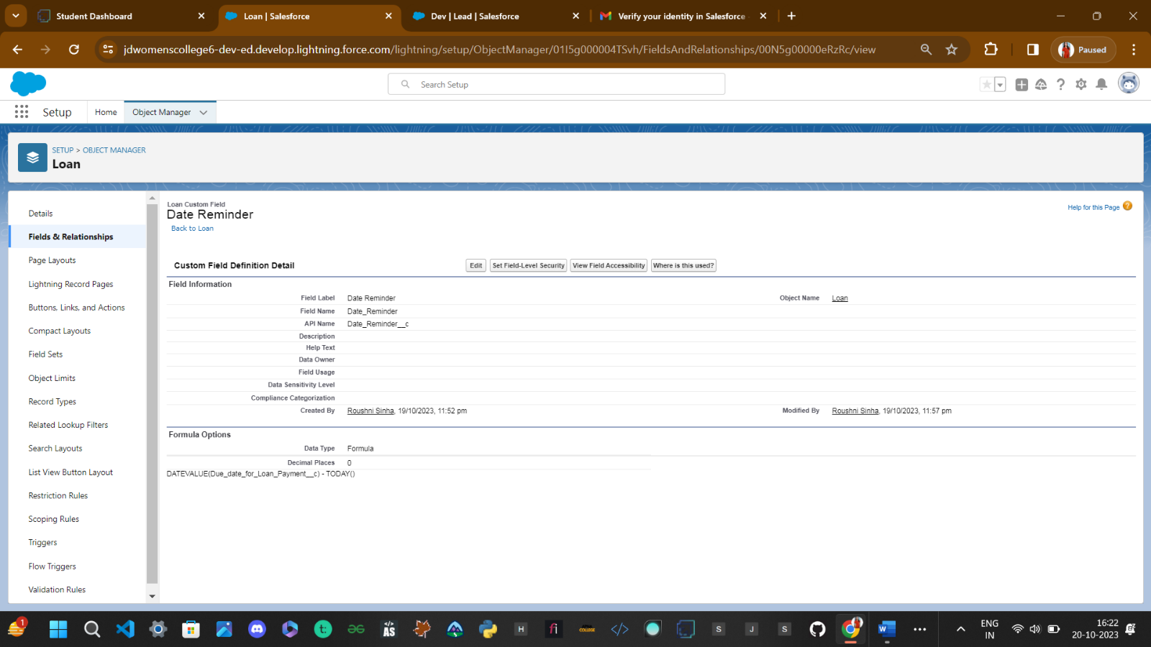

**14.1.2 Steps to create classic Email Template..**

Go to the Gear Icon->

Click on the home button and Search for the Classic Email Template->

Click on the New Template

->name -> Loan Amount Pay Reminder

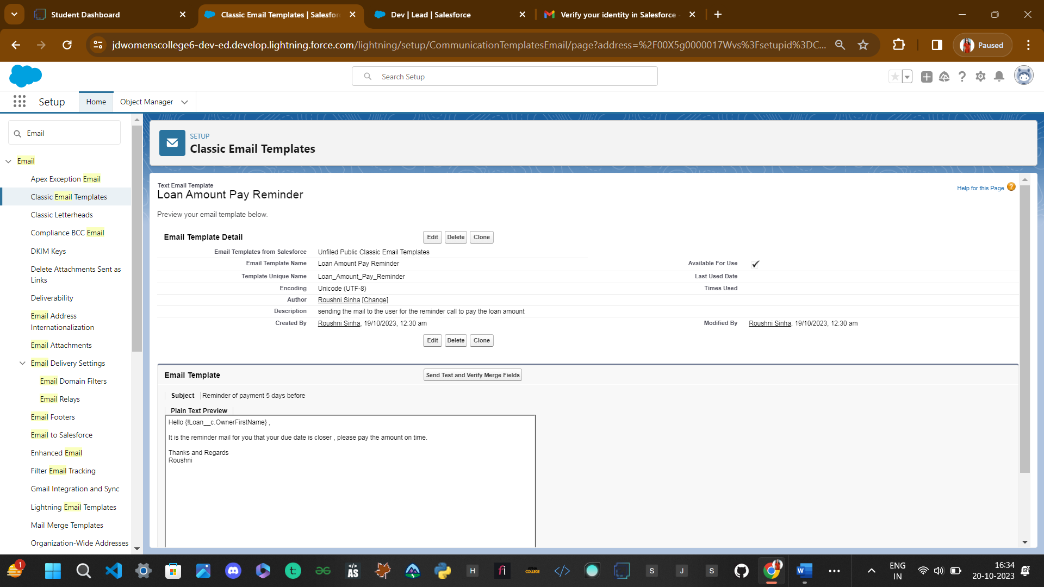

Clone that Email Template

And follow the steps which is mentioned above and give the following names you have to clone it multiple times that template

1. Loan Amount pay Reminder for 24 hrs

2. Overdue by one day

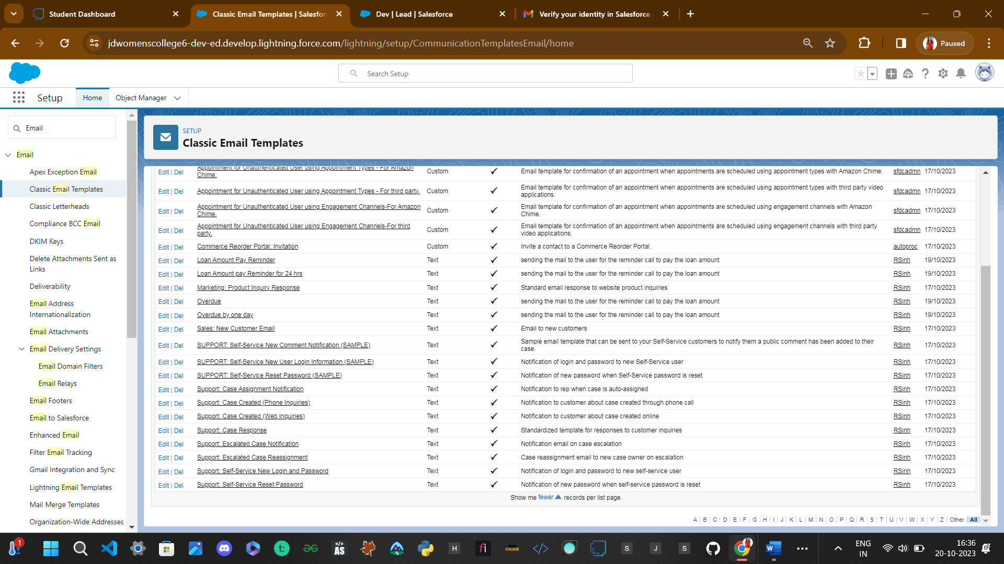3. Overdue

**14.2Create the Email Alerts**

Click on the home button and search for the Email Alerts  --->

There Click on the New Email alerts---->

and give the name as Email For the 24 hrs before--->

select the email template which you have created for the 24 hrs before and recipient for all condition is owner

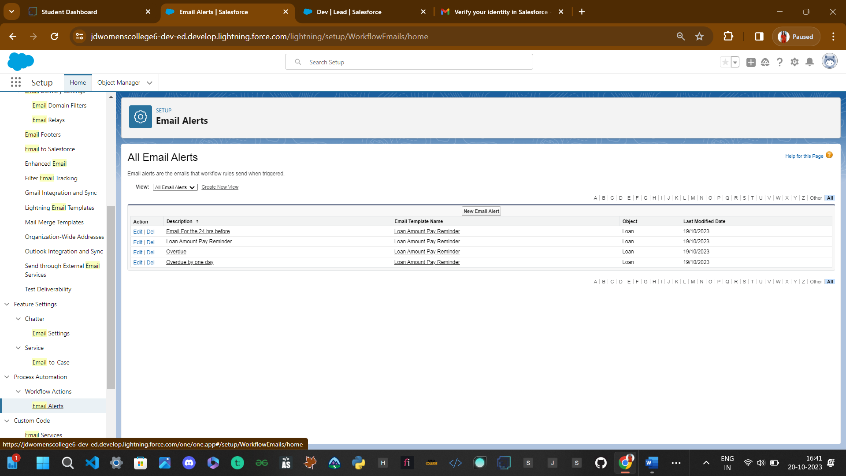

Follow the Above steps and create the Following Email Alert by cloning with the Similar steps

1. Loan Amount Pay Reminder(Cloned Email Alert)

2. Overdue by one day(Cloned Email Alert)

3. Overdue(Cloned Email Alert)

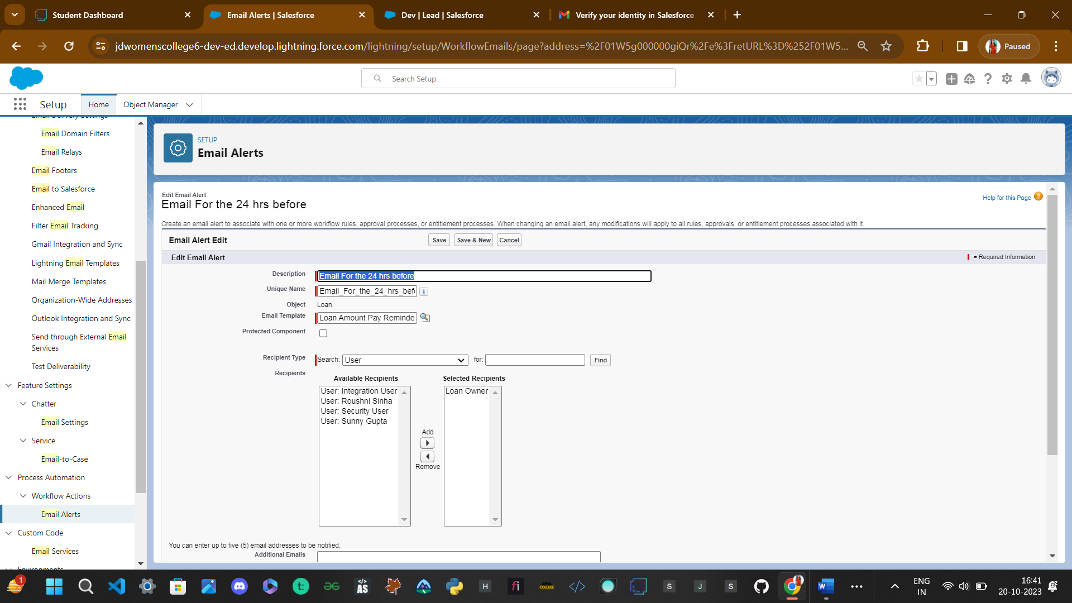

**14.3Create the Flows**

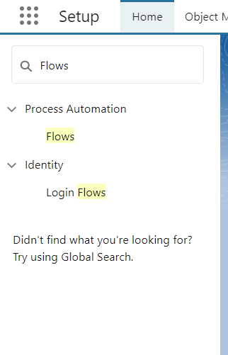

Steps to create FLOW Builder -> name: Email Alert

* Go to the Home Button and search for the flow
* Click on the New Flow---->Click on the Record Trigger Flow

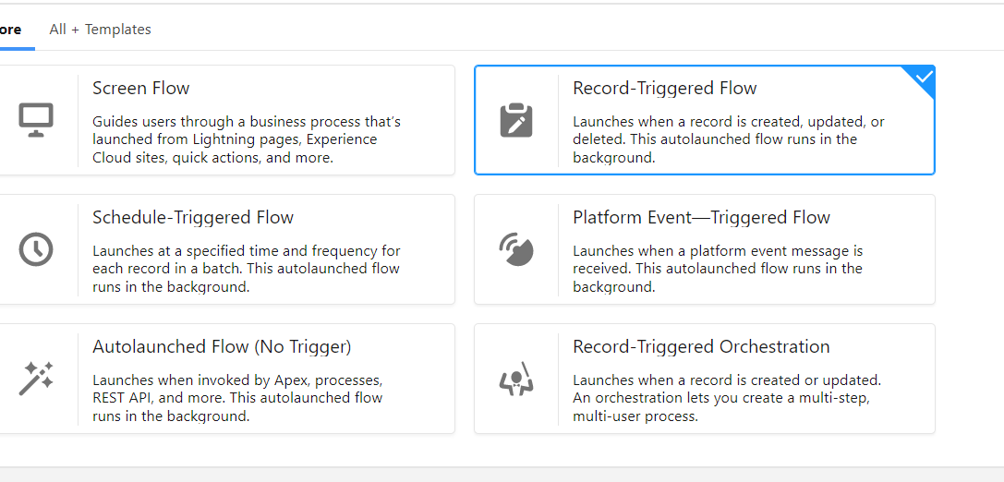

* Select the loan__c object----> Trigger the Flow When----> A Record is created or updated
* Condition Requirement?All Conditions are met (AND) ----> Field---->Due Date For the Loan PaymentOperator as --->is Nullvalue False

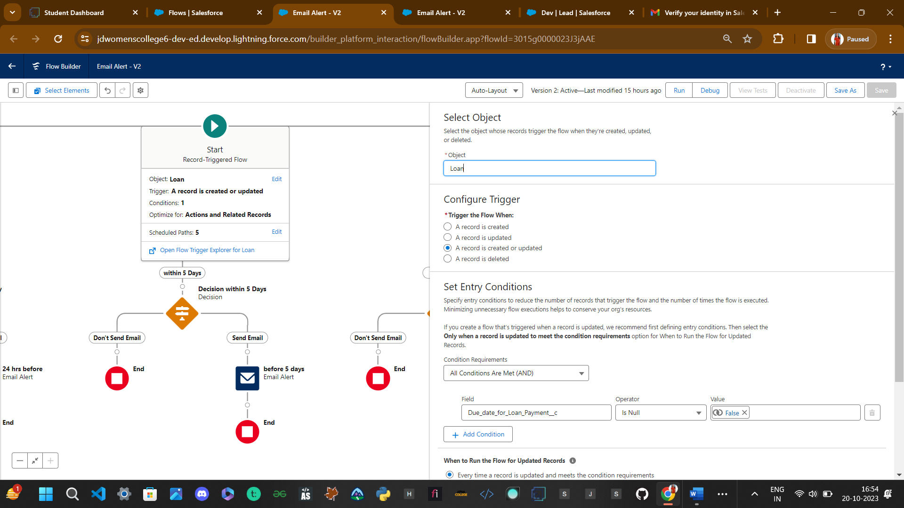

* Click on the Schedule path----> Path Label as---->within 1 Day----> API Name within_1_day?

               Time Source? Loan__c:Due Date Loan payment ---> Offset number 24----> offset option

* And create 4 Schedule Path-

1.within_1_Day 2. Within_5_Days 3. Overdue 4.Overdue a day

**Within 1 day schedule Path-**

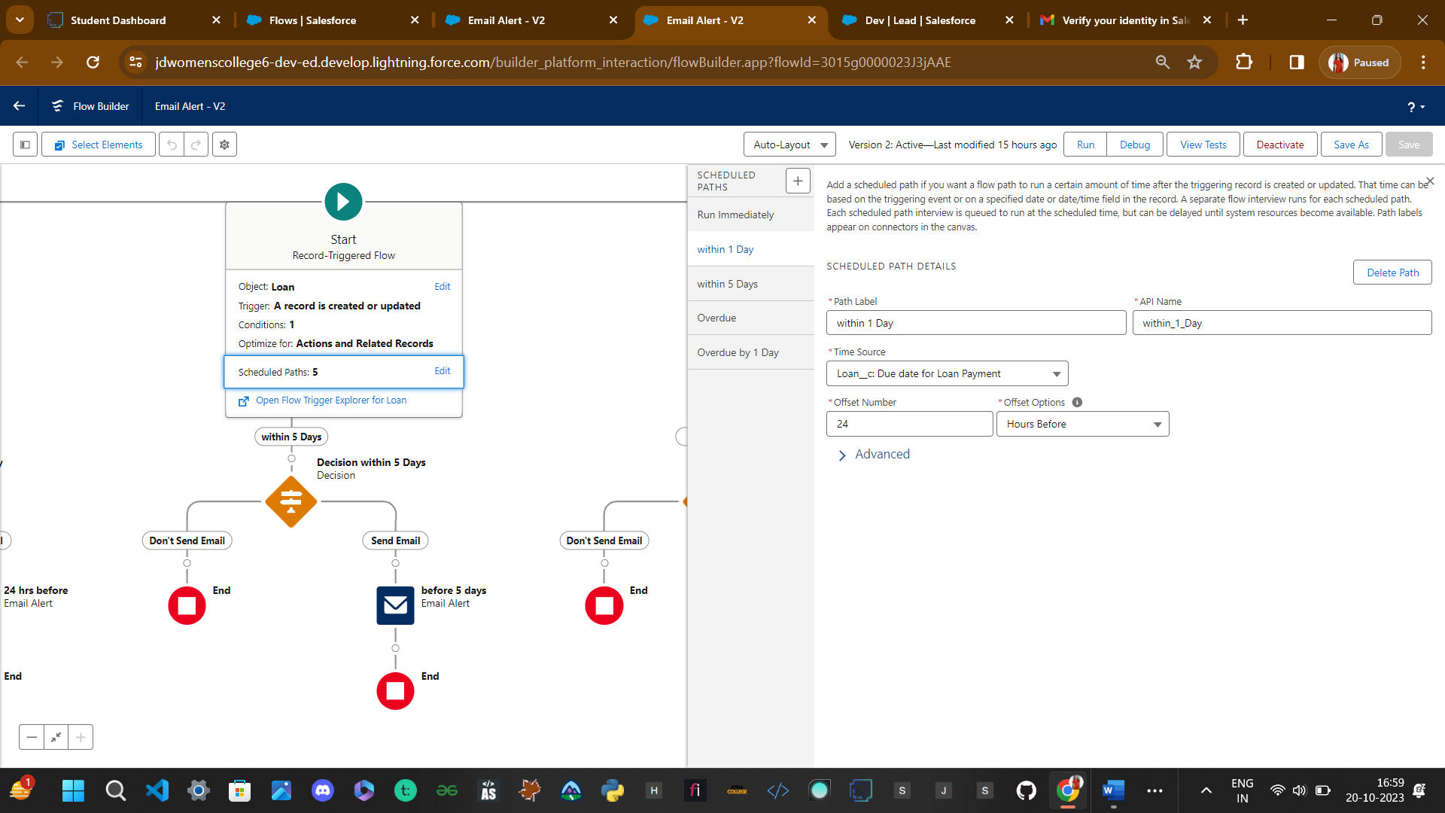

**Within 5 Days Schedule Path**

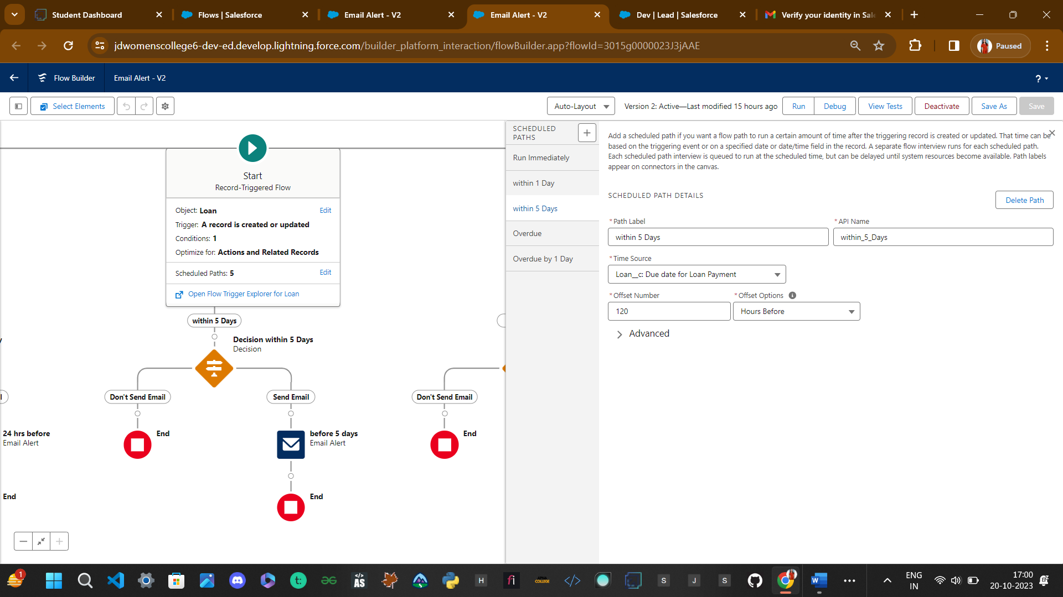

Overdue Schedule Path-

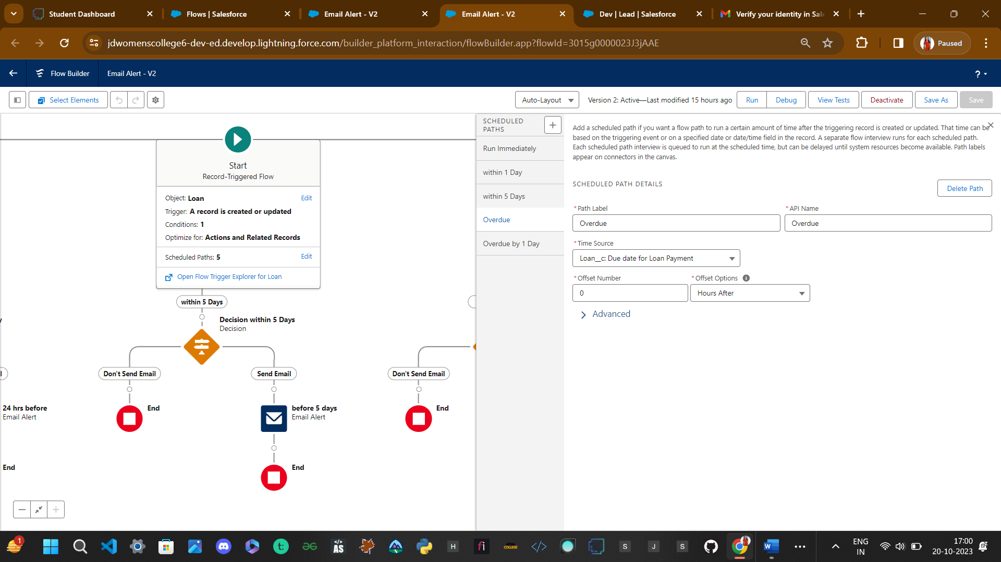

**Overdue by 1 day Scheduled path**

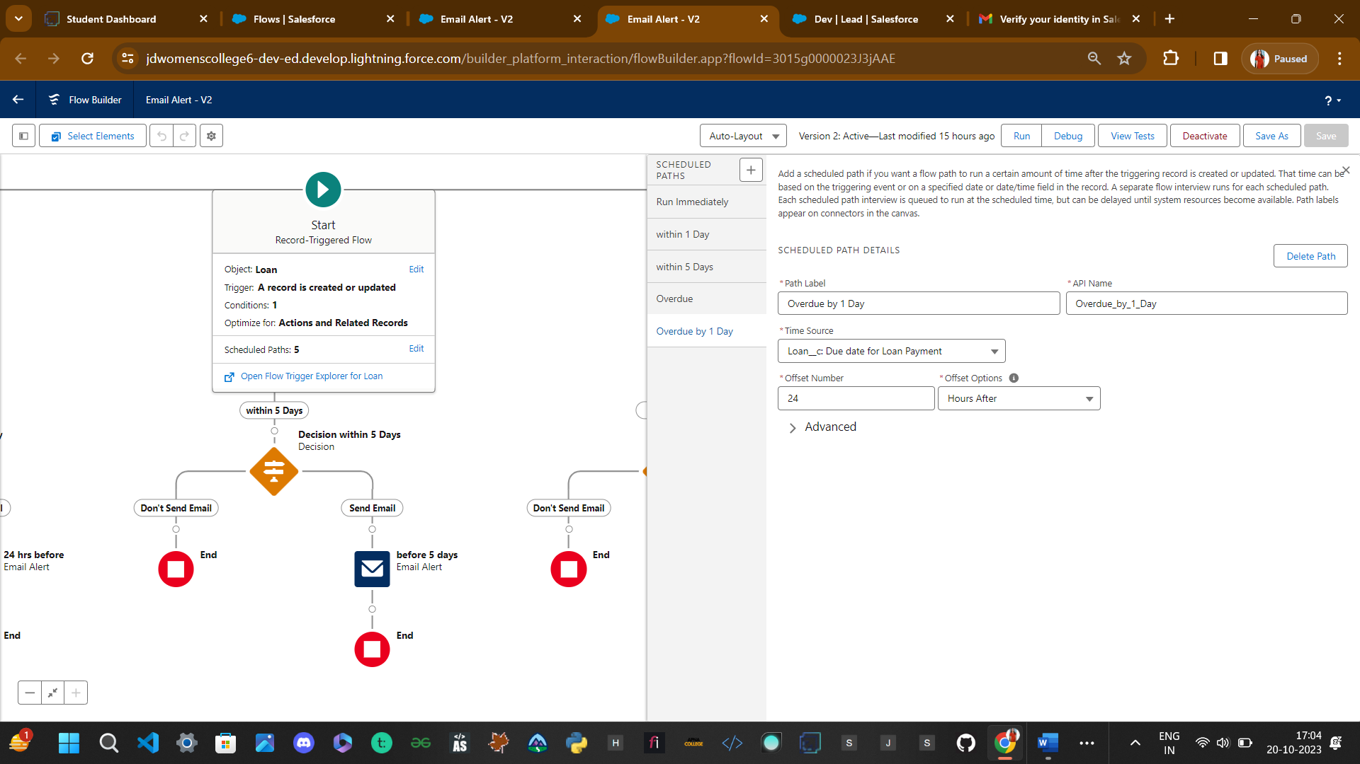

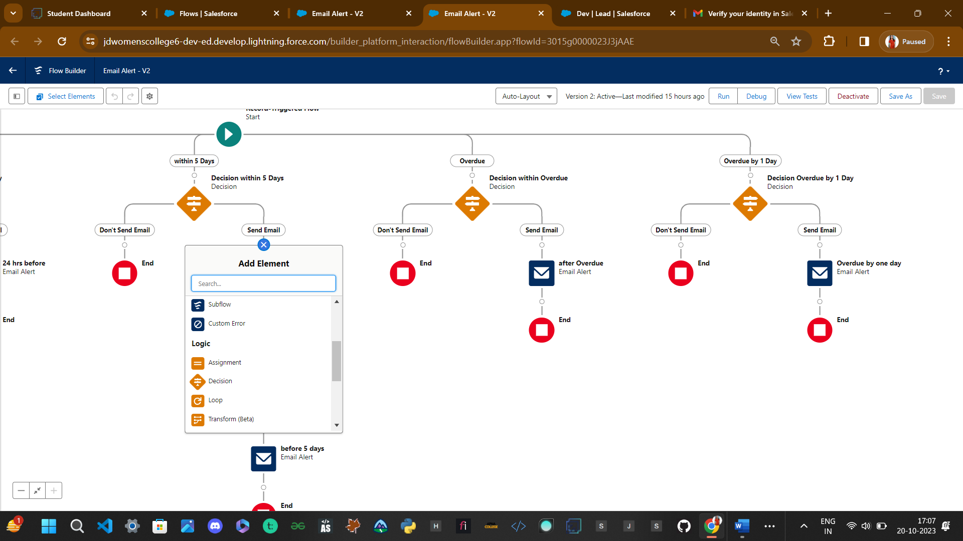**14.4Decision Elements**

Now for Decision Elements elect dot from each Scheduled Path and search “decision Elements”

Than There is Decision for the just click on add----> select the Decision--->order outcomet--->here are two outcome 1. Send Email 2. don’t send the email

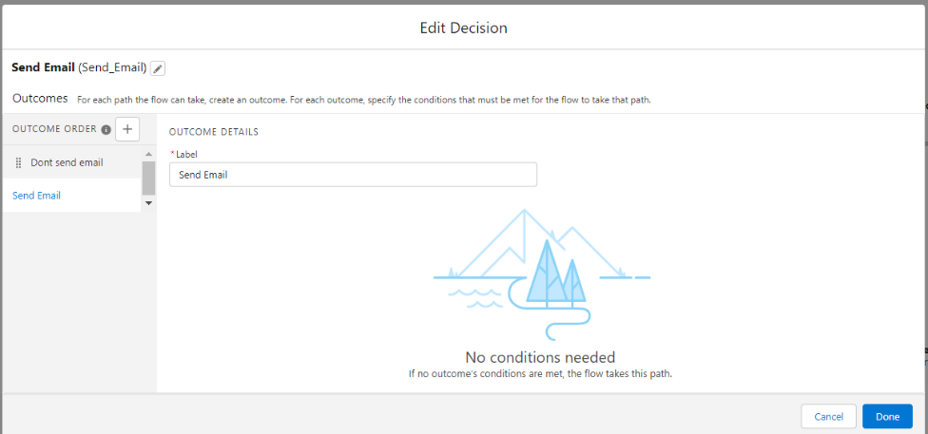

* On the outcome is there is the condition for that label don the send email ----> condition Requirement All Conditions are met (AND) ? Operator less than 1

• Follow the same steps for the Following

• On the outcome is there is the condition for that label done the send the email---> condition Requirement All Conditions are met (AND) ----> Operator less than 5

• On the outcome is there is the condition for that label Dont send email for this ----> condition Requirement All Conditions are met (AND) ----> Operator Greater than 0

• On the outcome is there is the condition for that label Dont Send the Email for this ----> condition Requirement All Conditions are met (AND) ----> Operator Greater than 1

* Before adding Decision element in each path -> first create Formulae Variable #DaysdueFromCreatedDate So that help to set trigger.

And formulae->

IF({!$Record.Date_Reminder__c} >= 0 ,

VALUE(TEXT({!$Record.Date_Reminder__c}) ) ,

VALUE(TEXT(ABS({!$Record.Date_Reminder__c} /-1)) ) )

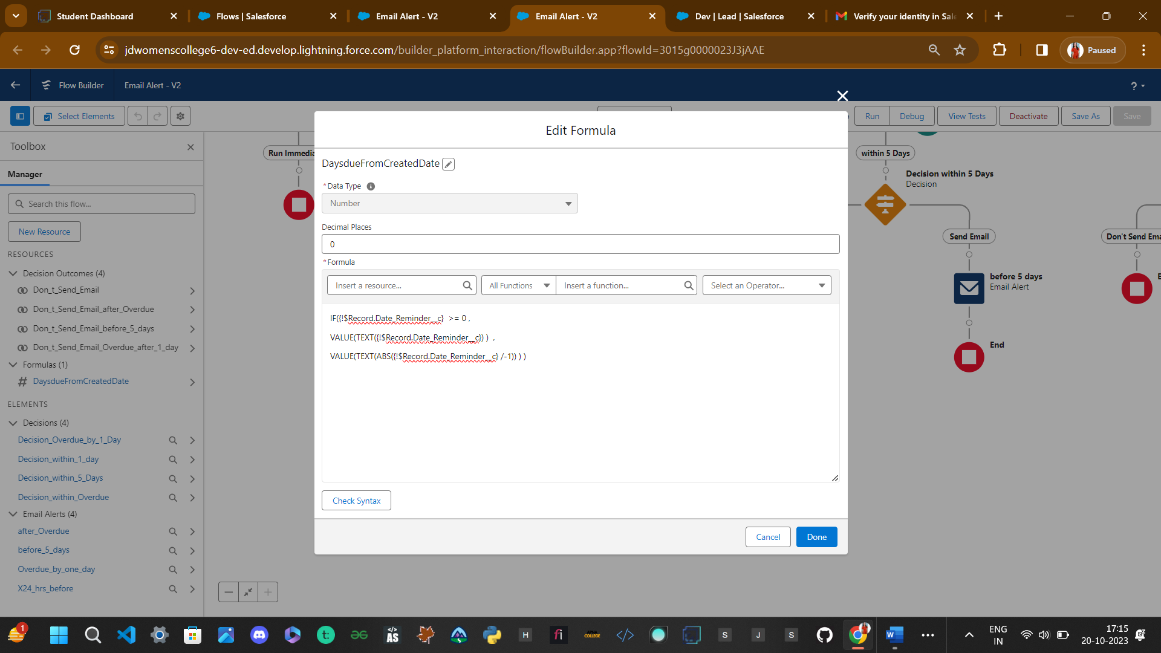

Within 1 Day ” Decision Elements”->

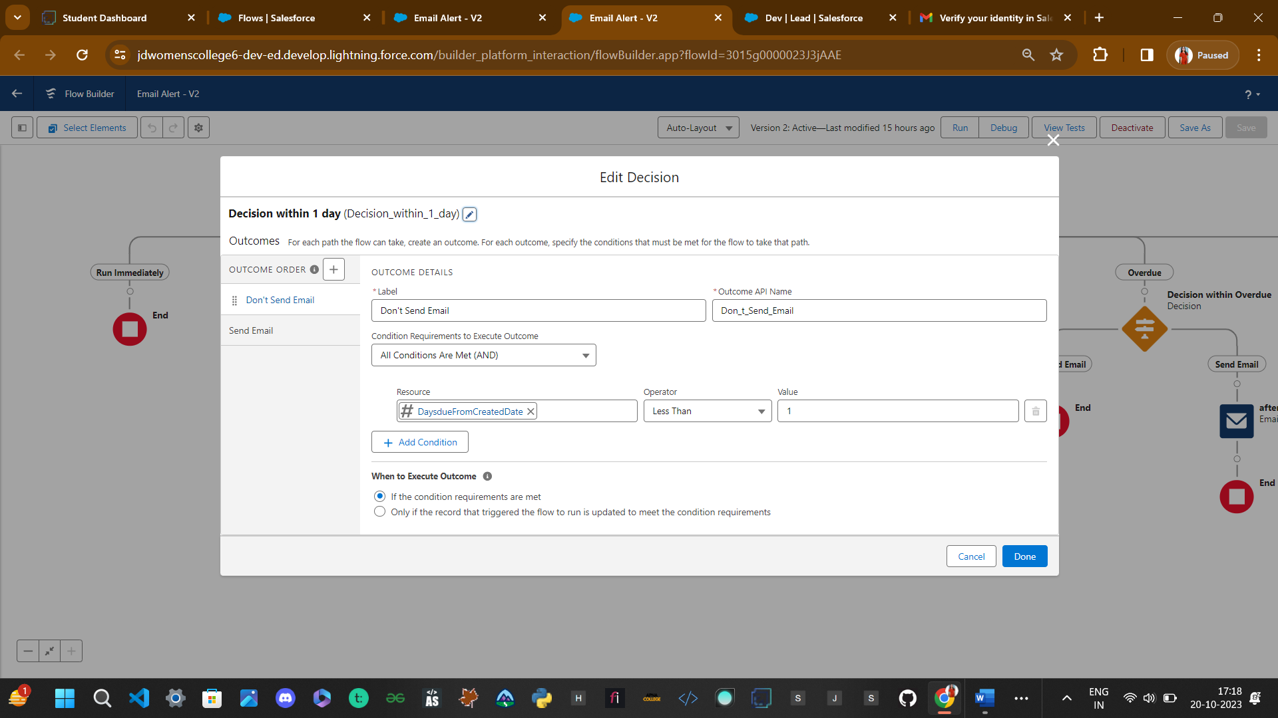

Within 5 Days Decision Elements->

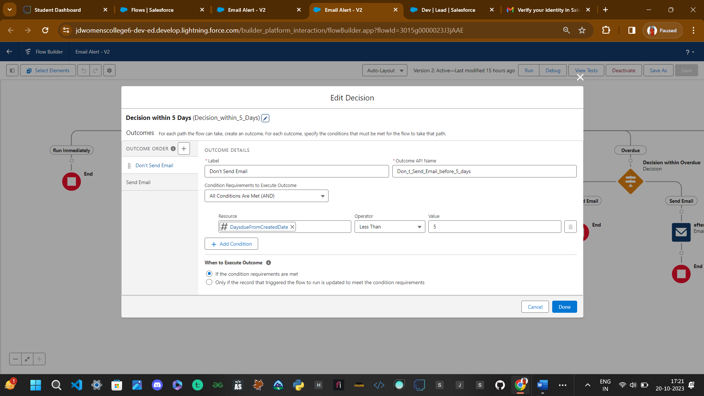

Overdue Decision Element->

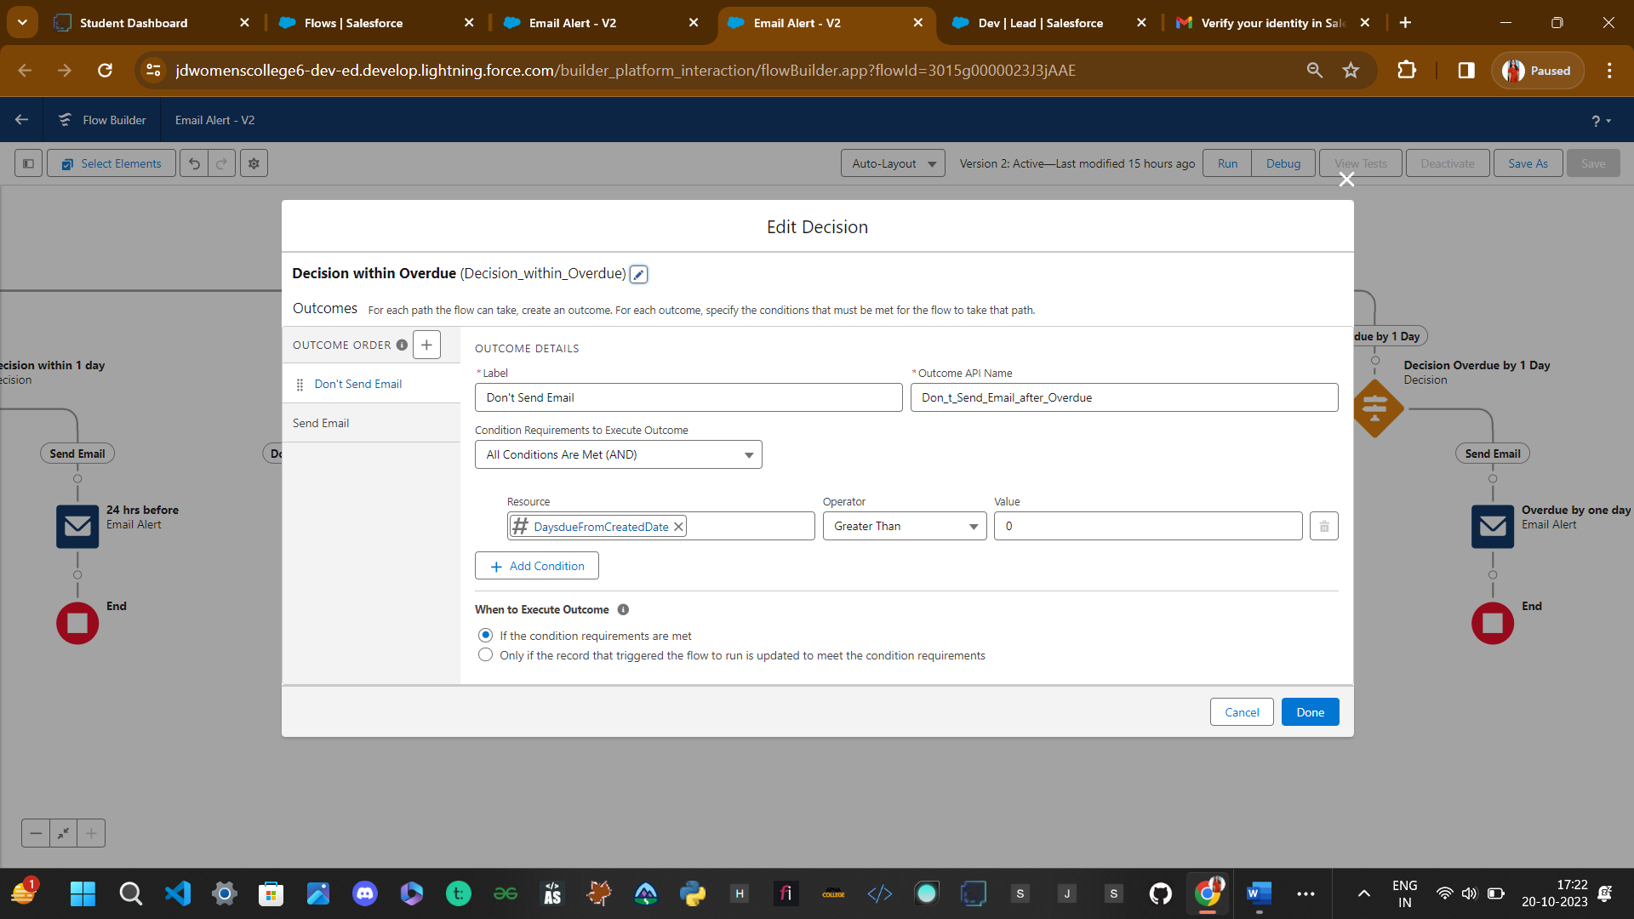

Overdue by 1 Day Decision Element->

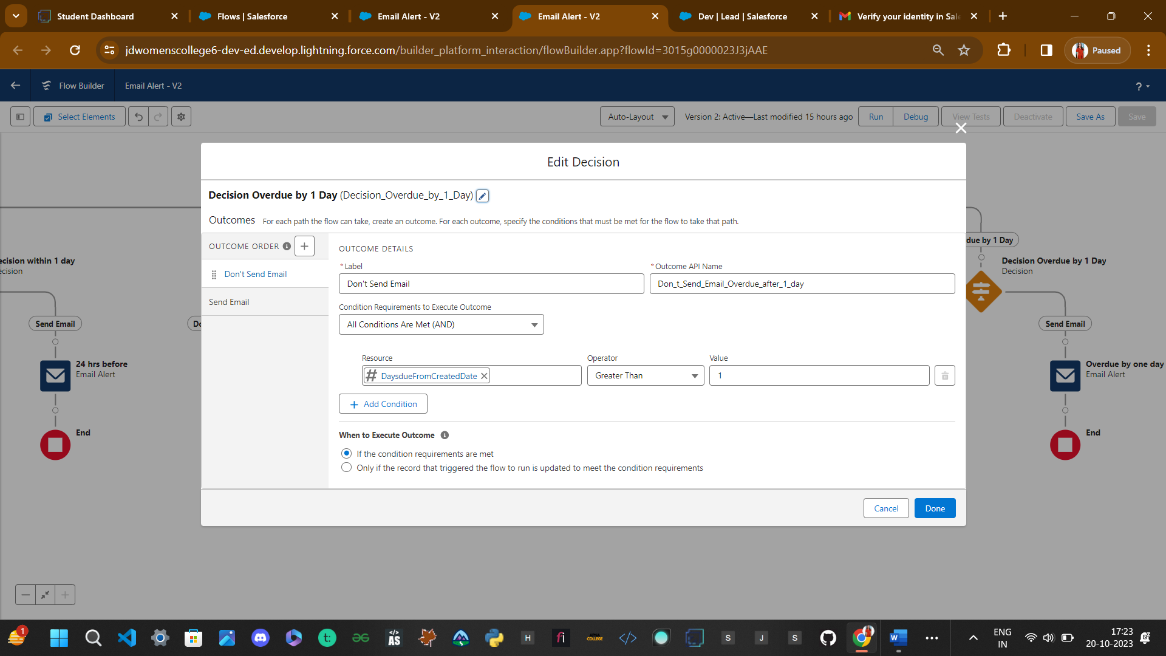

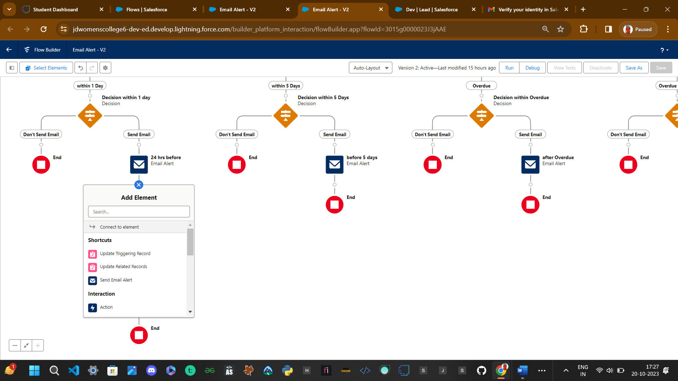Now add Email Alert Element At SEND Email Outcome of Decision Element in Each Scheduled Path with all Four Email Alert are made.

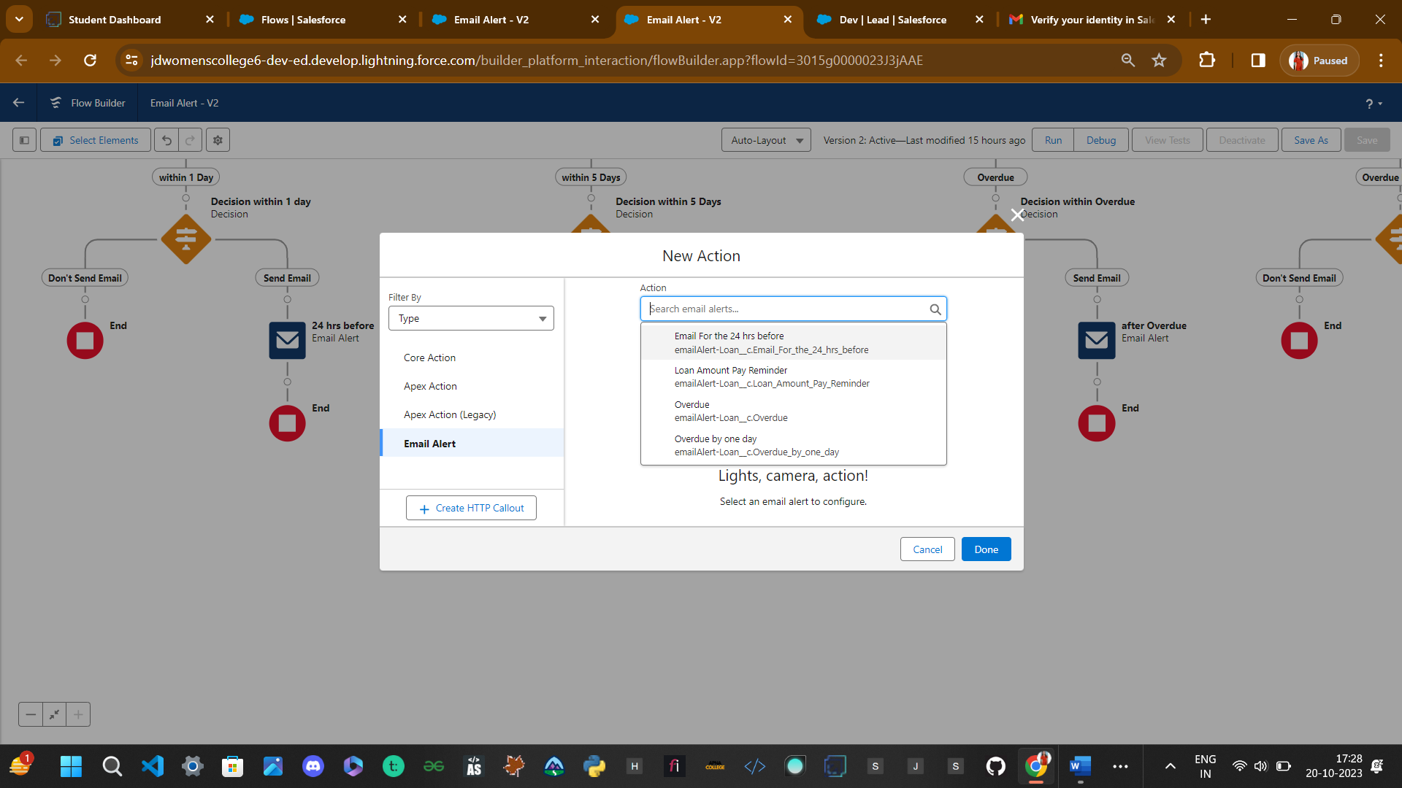

24 hr email alert->

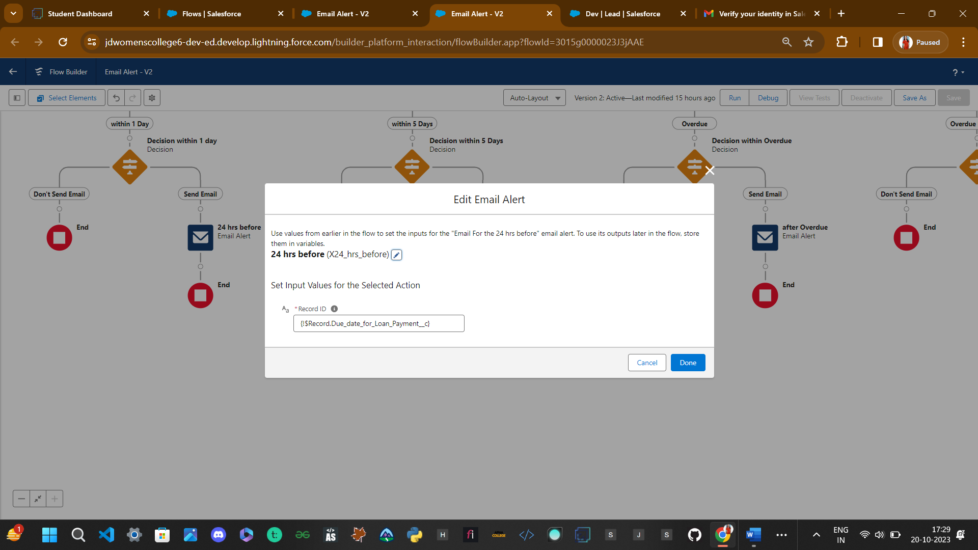

Now Flow is saved and Activate->

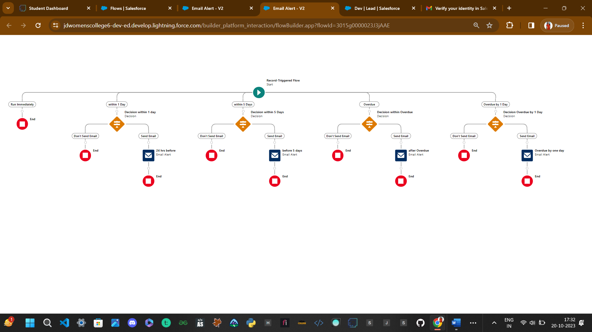

Step 15: Create Appex Trigger

Apex Triggers

Apex can be invoked by using triggers. Apex triggers enable you to perform custom actions

before or after changes to Salesforce records, such as insertions, updates, or deletions.

A trigger is Apex code that executes before or after the following types of operations:

Insert update delete merge upsert undelete

For example, you can have a trigger run before an object's records are inserted into the database,

after records have been deleted, or even after a record is restored from the Recycle Bin.

You can define triggers for top-level standard objects that support triggers, such as a Contact

or an Account, some standard child objects, such as a CaseComment, and custom objects. To

define a trigger, from the object management settings for the object whose triggers you want

to access, go to Triggers.

Use Case: When We Are Changing the property type form “Commercial” to “Residential” the

Than commercial field should with “Shop”

**Use Case:** Apex Trigger is Related  to Property Object in that there is the field “Create Property Type” which is having the picklist values in that field(Residential, Commercial, Industrial) the condition is like if we select the Create Property type as “Residential” than there is  Commercial field so it should get populated with “Shop”

**Apex Class:**

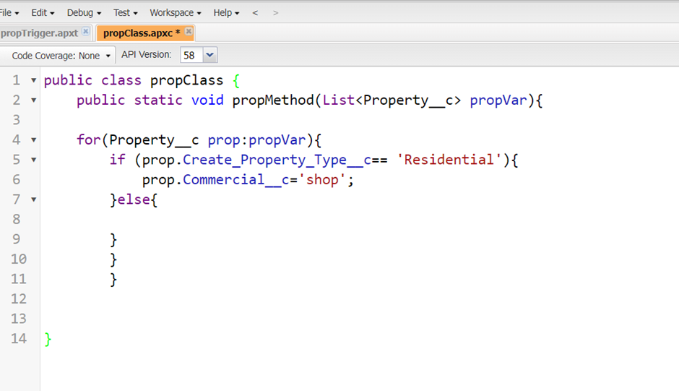

**Apex Triggers:**

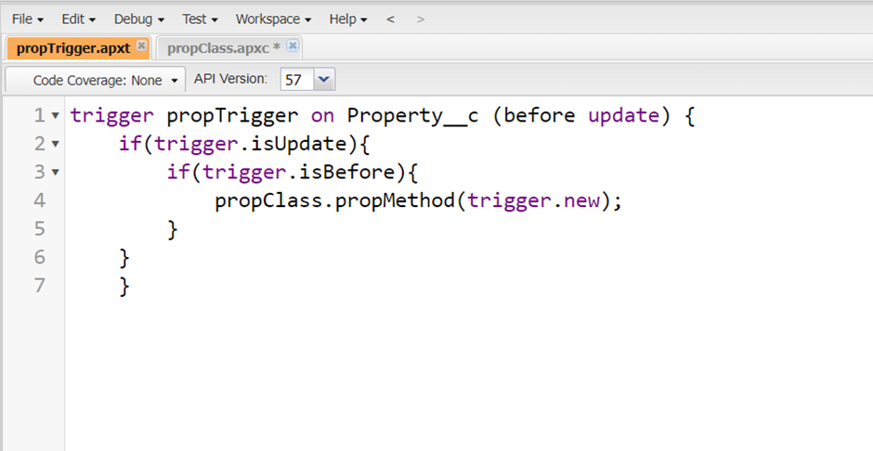

**END OF THE PROPERTY MANAGEMENT PROJECT**

**THANK YOU**